Serial Robot Kinematics

Alex Thompson (10004785)

Table of Contents

1. Introduction 3

2. Kinematics 3

Robot Arm Specifications 3

DH table and diagram 5

Forward Kinematics 6

Workspace 9

Matlab Approach 9

Geometric Approach 10

Inverse Kinematics 12

Geometric Approach 12

Task 15

Home position 15

Above object 16

Grasping object 17

Above end goal 18

Releasing object 19

Kinematics Summary 20

3. Intelligence 21

4. Appendix 22

1.0 Matlab Code 22

1.1 Solving T1E Using Matlab: 22

1.2 Testing the Forward Kinematics 22

1.3 Calculating the workspace 23

1.4 Simulating the Arm 25

1.5 Testing Inverse Kinematics 26

2.0 Math 27

2.1 Trigonometric Identities 27

2.2 Forward kinematics 27

5. References 29

# Introduction

This report focuses on a serial robot arm called the lynx motion. Its aim is to explore the kinematics of this arm. The report is divided into three main parts:

1. The kinematics of the arm including deriving the forward kinematics, inverse kinematics, workspace, simulated testing of the kinematics solutions, and real world testing.
2. Artificial Intelligence techniques including deriving an ANFIS representation of the IK of the arm, simulated testing of the IK generated in this manner, and real world testing.
3. An expansion on the required kinematics including a GUI interface for control of a simulated lynx motion arm, and a machine vision system for using the lynx motion arm to draw pictures given to it by a webcam.

# Kinematics

## Robot Arm Specifications

The arm used in this report was #10.

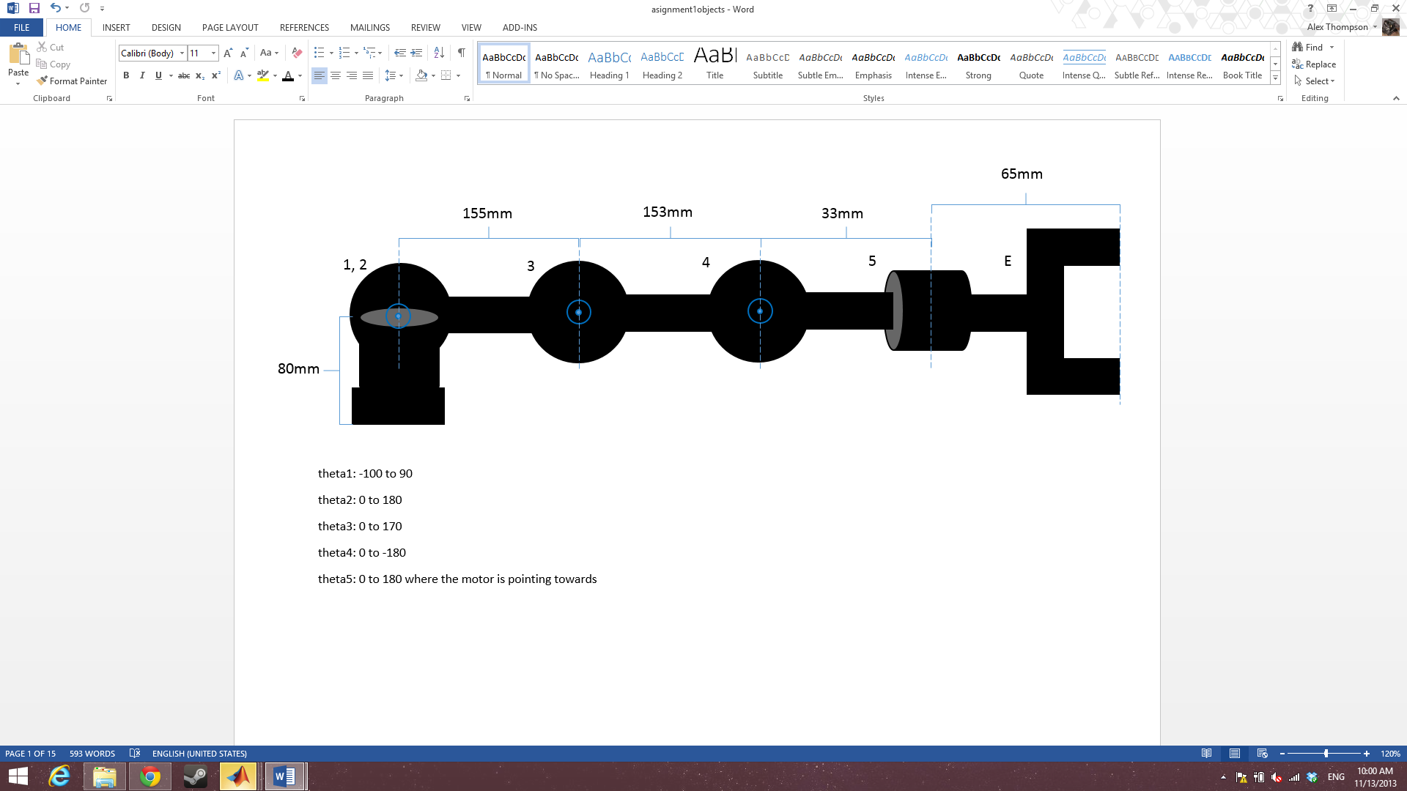

Figure 1

|  |  |
| --- | --- |
| **part** | **length** |
| base to shoulder | 85mm |
| shoulder to elbow | 93mm |
| elbow to wrist | 108mm |
| wrist to rotator | 33mm |
| rotator to end effector | 37mm |

|  |  |
| --- | --- |
| joint | **rotation limitations** |
| $$θ_{1}$$ | -105 to 100 |
| $$θ_{2}$$ | 0 to 140 |
| $$θ_{3}$$ | 0 to -160 |
| $$θ_{4}$$ | -110 to 70 *needs to be fixed |
| $$θ_{5}$$ | -100 to 100 |

servo min: 500

servo max: 2500

$$\frac{range motor}{range in degree}=\frac{2500-500}{180}$$

## DH table and diagram

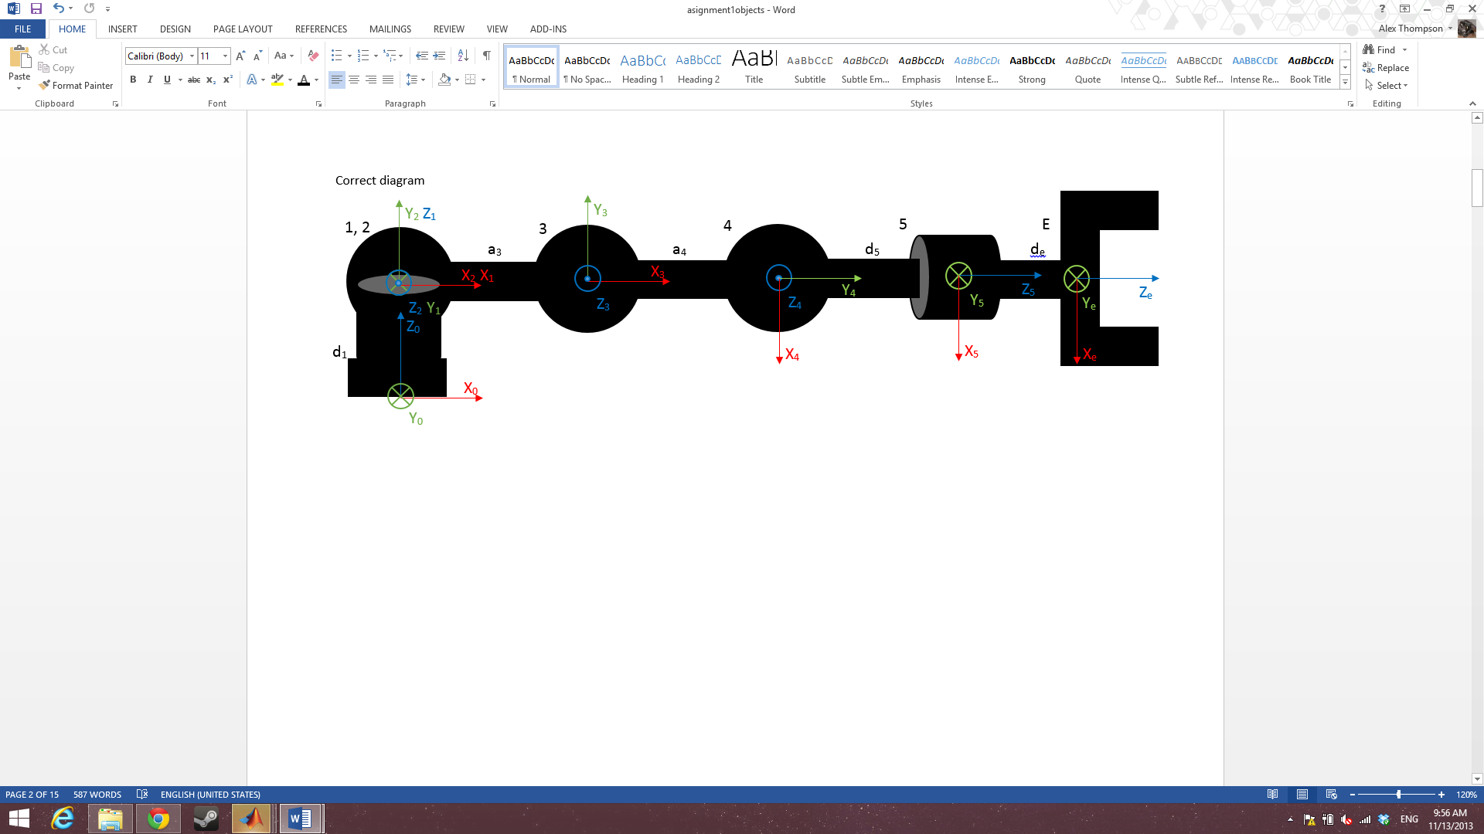

Figure 2

To choose the orientation of each frame I aligned z along the axis of rotation for each joint.

|  |  |  |  |  |
| --- | --- | --- | --- | --- |
| i | αi-1 | ai-1 | di-1 |  |
| 1 | 0 | 0 | d1 |  |
| 2 | 90 | 0 | 0 |  |
| 3 | 0 | a3 | 0 |  |
| 4 | 0 | a4 | 0 |  |
| 5 | -90 | 0 | d5 |  |
| E | 0 | 0 | dE |  |

The DH table was derived using the proximal methodology. Each element of it is found using the following:

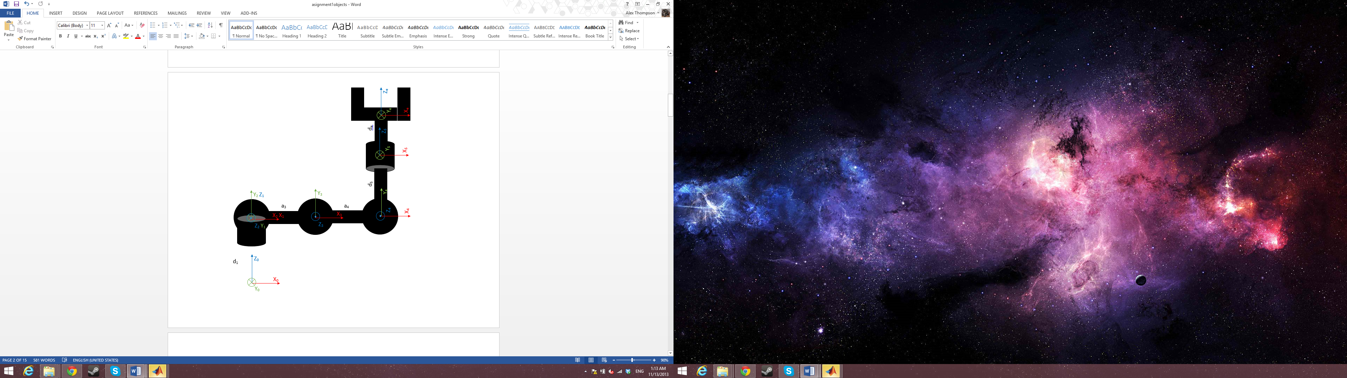alpha is the rotation about the x axis when comparing i-1 to i.

a is the distance traveled along the x axis from i-1 to i.

d is the distance traveled along the z axis from i-1 to i.

$θ$ is the rotation about the z axis when comparing i-1 to i.

An exception to the above that came into play is that when

When all theta=0 the arms orientation is:

Figure 3

## Forward Kinematics

Using the generalized equation for proximal

$${}_{i}^{i-1}T=\left[\begin{matrix}\cos{θ_{i}} & -\sin{θ_{i}} & 0 & a_{i-1} \\ \sin{θ_{i}}\cos{α_{i-1}} & \cos{θ_{i}}\cos{α_{i-1}} & -\sin{α_{i-1}} & -\sin{α_{i-1}}d_{i} \\ \sin{θ_{i}}\sin{α_{i-1}} & \cos{θ_{i}}\sin{α_{i-1}} & \cos{α_{i-1}} & \cos{α_{i-1}}d_{i} \\ 0 & 0 & 0 & 1\end{matrix}\right]$$

$${}_{1}^{0}T=\left[\begin{matrix}\cos{θ_{1}} & -\sin{θ_{1}} & 0 & 0 \\ \sin{θ_{1}}\cos{(0)} & \cos{θ_{1}}\cos{(0)} & -\sin{(0)} & -\sin{(0)}d_{1} \\ \sin{θ_{1}}\sin{(0)} & \cos{θ_{1}}\sin{(0)} & \cos{(0)} & \cos{(0)}d_{1} \\ 0 & 0 & 0 & 1\end{matrix}\right]=\left[\begin{matrix}\cos{θ_{1}} & -\sin{θ_{1}} & 0 & 0 \\ \sin{θ_{1}} & \cos{θ_{1}} & 0 & 0 \\ 0 & 0 & 1 & d_{1} \\ 0 & 0 & 0 & 1\end{matrix}\right]$$

$${}_{2}^{1}T=\left[\begin{matrix}\cos{θ_{2}} & -\sin{θ_{2}} & 0 & 0 \\ \sin{θ_{2}}\cos{(90)} & \cos{θ_{2}}\cos{(90)} & -\sin{(90)} & -\sin\left(90\right)(0) \\ \sin{θ_{2}}\sin{(90)} & \cos{θ_{2}}\sin{(90)} & \cos{(90)} & \cos{(90)}(0) \\ 0 & 0 & 0 & 1\end{matrix}\right]=\left[\begin{matrix}\cos{θ_{2}} & -\sin{θ_{2}} & 0 & 0 \\ 0 & 0 & -1 & 0 \\ \sin{θ_{2}} & \cos{θ_{2}} & 0 & 0 \\ 0 & 0 & 0 & 1\end{matrix}\right]$$

$${}_{3}^{2}T=\left[\begin{matrix}\cos{θ_{3}} & -\sin{θ_{3}} & 0 & a_{3} \\ \sin{θ_{3}}\cos{(0)} & \cos{θ_{3}}\cos{(0)} & -\sin{(0)} & -\sin{(0)}(0) \\ \sin{θ_{3}}\sin{(0)} & \cos{θ_{3}}\sin{(0)} & \cos{(0)} & \cos{(0)}(0) \\ 0 & 0 & 0 & 1\end{matrix}\right]=\left[\begin{matrix}\cos{θ_{3}} & -\sin{θ_{3}} & 0 & a_{3} \\ \sin{θ_{3}} & \cos{θ_{3}} & 0 & 0 \\ 0 & 0 & 1 & 0 \\ 0 & 0 & 0 & 1\end{matrix}\right]$$

$${}_{4}^{3}T=\left[\begin{matrix}\cos{θ_{4}} & -\sin{θ_{4}} & 0 & a_{4} \\ \sin{θ_{4}}\cos{(0)} & \cos{θ_{4}}\cos{(0)} & -\sin{(0)} & -\sin{(0)}(0) \\ \sin{θ_{4}}\sin{(0)} & \cos{θ_{4}}\sin{(0)} & \cos{(0)} & \cos{(0)}(0) \\ 0 & 0 & 0 & 1\end{matrix}\right]=\left[\begin{matrix}\cos{θ_{4}} & -\sin{θ_{4}} & 0 & a_{4} \\ \sin{θ_{4}} & \cos{θ_{4}} & 0 & 0 \\ 0 & 0 & 1 & 0 \\ 0 & 0 & 0 & 1\end{matrix}\right]$$

$${}_{5}^{4}T=\left[\begin{matrix}\cos{θ_{5}} & -\sin{θ_{5}} & 0 & 0 \\ \sin{θ_{5}}\cos{(-90)} & \cos{θ_{5}}\cos{(-90)} & -\sin{(-90)} & -\sin{(-90)}d_{5} \\ \sin{θ_{5}}\sin{(-90)} & \cos{θ_{5}}\sin{(-90)} & \cos{(-90)} & \cos{(-90)}d_{5} \\ 0 & 0 & 0 & 1\end{matrix}\right]=\left[\begin{matrix}\cos{θ_{5}} & -\sin{θ_{5}} & 0 & 0 \\ 0 & 0 & 1 & d_{5} \\ -sin{θ_{5}} & -cos{θ_{5}} & 0 & 0 \\ 0 & 0 & 0 & 1\end{matrix}\right]$$

$${}_{E}^{5}T=\left[\begin{matrix}\cos{θ_{E}} & -\sin{θ_{E}} & 0 & 0 \\ \sin{θ_{E}}\cos{(0)} & \cos{θ_{E}}\cos{(0)} & -\sin{(0)} & -\sin{(0)}d_{E} \\ \sin{θ_{E}}\sin{(0)} & \cos{θ_{E}}\sin{(0)} & \cos{(0)} & \cos{(0)}d_{E} \\ 0 & 0 & 0 & 1\end{matrix}\right]=\left[\begin{matrix}1 & 0 & 0 & 0 \\ 0 & 1 & 0 & 0 \\ 0 & 0 & 1 & d_{E} \\ 0 & 0 & 0 & 1\end{matrix}\right]$$

$${}_{1}^{0}T{}_{2}^{1}T{}_{3}^{2}T{}_{4}^{3}T{}_{5}^{4}T=\left[\begin{matrix}r_{11} & r_{12} & r_{13} & p_{x} \\ r_{21} & r_{22} & r_{23} & p_{y} \\ r_{31} & r_{32} & r_{33} & p_{z} \\ 0 & 0 & 0 & 1\end{matrix}\right]$$

See appendix 2.2 for the values of the above matrix

Using:

$\sin\left(θ_{i}\right)=S_{i}$

$$\cos{(θ_{i})}=C_{i}$$

$$\sin\left(θ_{i}+θ_{j}\right)=S_{ij}$$

$$\cos{(θ_{i}+θ_{j})}=C_{ij}$$

$$\left[\begin{matrix}r_{11} & r_{12} & r_{13} \\ r_{21} & r_{22} & r_{23} \\ r_{31} & r_{32} & r_{33}\end{matrix}\right]=\left[\begin{matrix}C_{234}C_{1}C_{5}-S_{1}S_{1} & -C_{5}S_{1}-C_{234}C_{1} & -S_{234}C_{1} \\ C_{1}S_{5}+C_{234}C_{5}S_{1} & C_{1}C_{5}-C_{234}S_{1}S_{5} & -S_{234}S_{1} \\ S_{234}C_{5} & -S_{234}S_{5} & C_{234}\end{matrix}\right]$$

$$\left[\begin{matrix}p_{x} \\ p_{y} \\ p_{z}\end{matrix}\right]=\left[\begin{matrix}C_{1}\left(a_{4}C_{23}+a_{3}C_{2}{-d}_{5}S_{234}{-d}_{E}S_{234}\right) \\ S_{1}\left(a_{4}C_{23}+a_{3}C_{2}{-d}_{5}S_{234}{-d}_{E}S_{234}\right) \\ d_{1}+a_{4}S_{23}+a_{3}S_{2}+d_{5}C_{234}+d_{E}C_{234}\end{matrix}\right]=\left[\begin{matrix}C_{1}\left(a_{4}C_{23}+a_{3}C_{2}-\left(d_{5}+d_{E}\right)S_{234}\right) \\ S_{1}\left(a_{4}C_{23}+a_{3}C_{2}-\left(d_{5}+d_{E}\right)S_{234}\right) \\ d_{1}+a_{4}S_{23}+a_{3}S_{2}+\left(d_{5}+d_{E}\right)C_{234}\end{matrix}\right]$$

I used Matlab to verify the accuracy of the above matrices (see appendix 1.1).

I then tested my forward kinematics in matlab to ensure I was getting appropriate results (see appendix 1.2)

Next, I simulated the arm in 3 positions to confirm that the kinematics were behaving properly (see appendix 1.4 for Matlab code).

theta1=0; theta2=0; theta3=0; theta4=0; theta5=0;

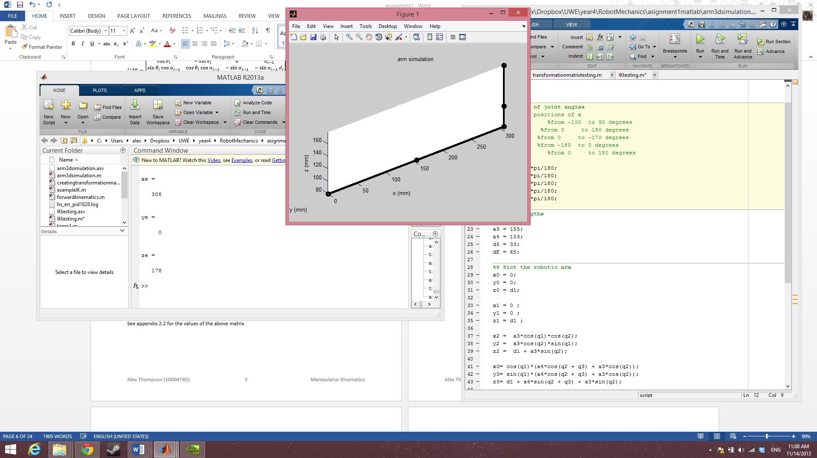 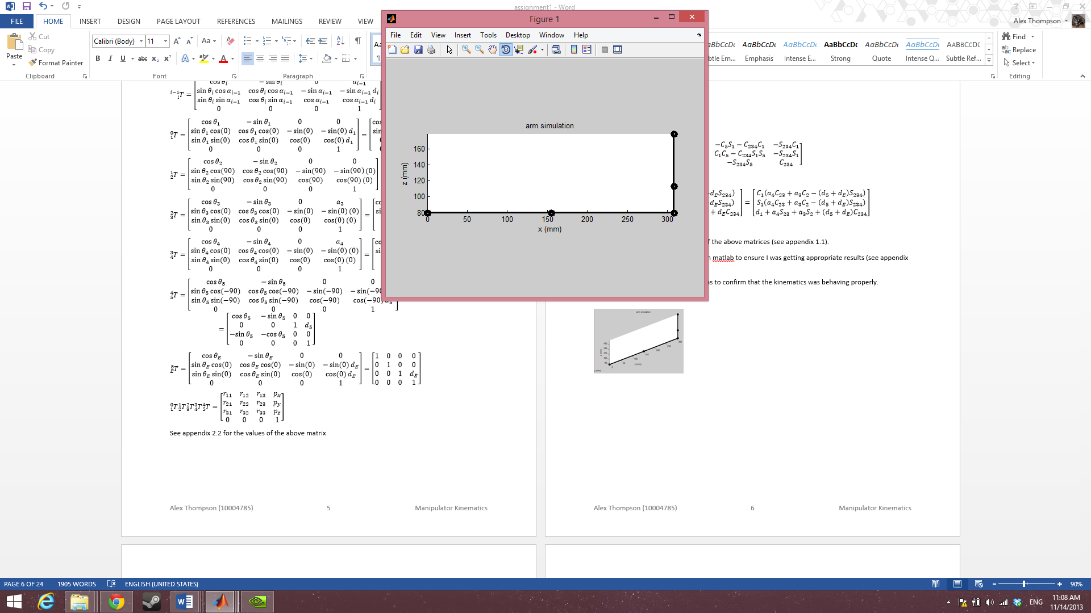

Figure 5

Figure 4

T1E =

1 0 0 308

0 1 0 0

0 0 1 178

0 0 0 1

theta1=0; theta2=90; theta3=-90; theta4=-90; theta5=50;

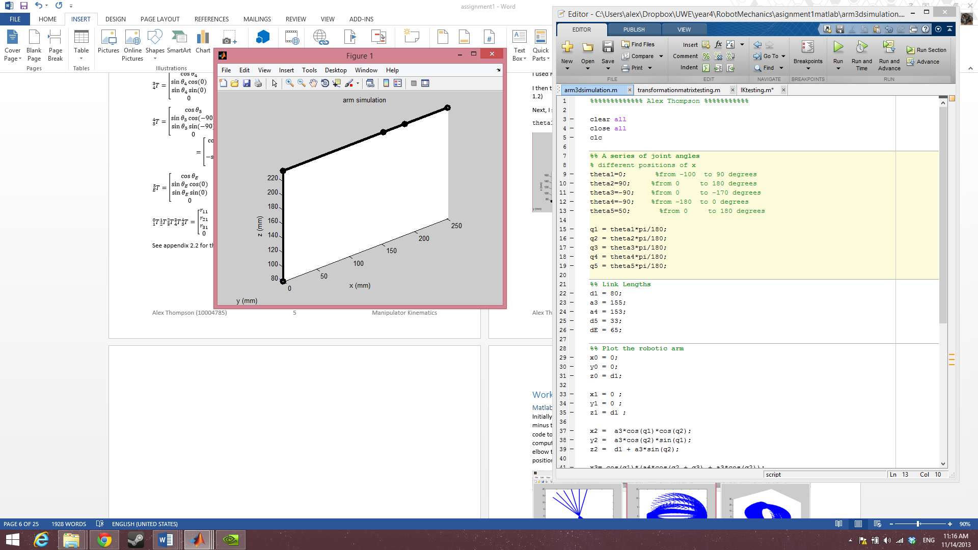 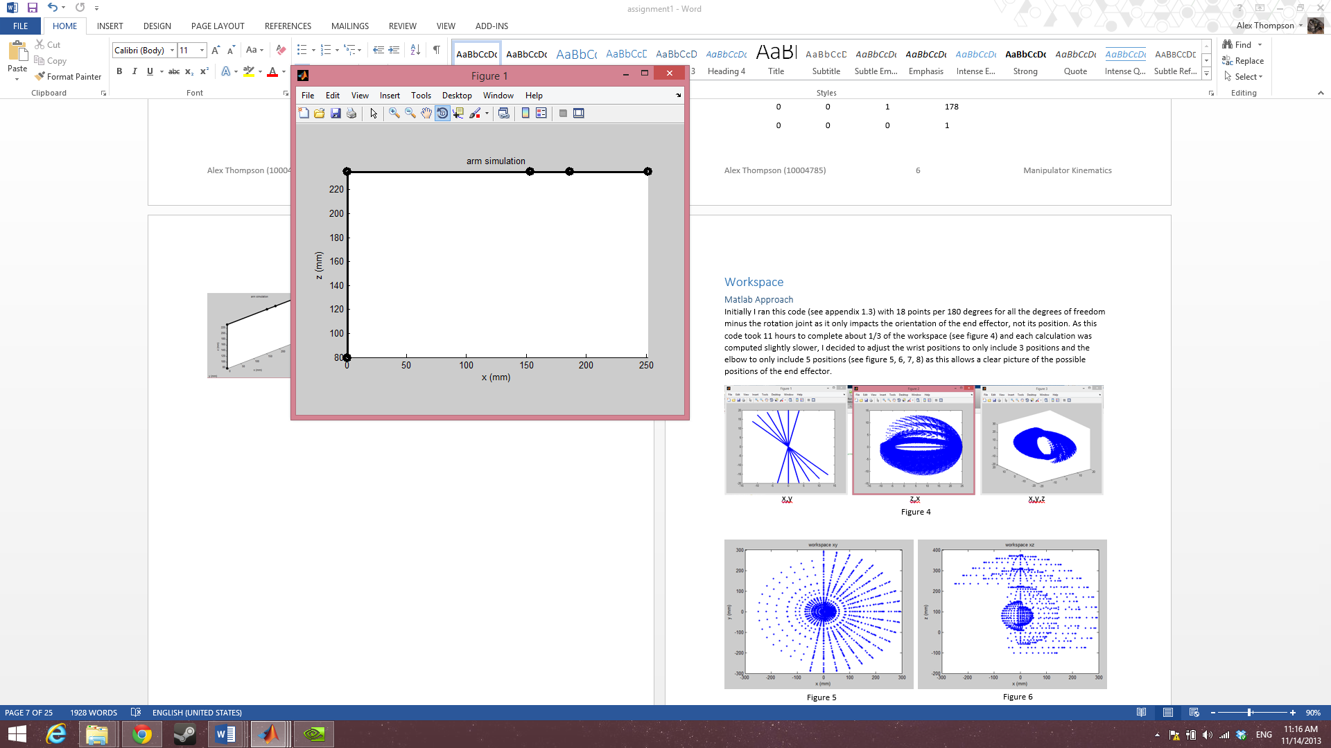

Figure 7

Figure 6

T1E =

0.0000 -0.0000 1.0000 251.0000

0.7660 0.6428 0 0

-0.6428 0.7660 0.0000 235.0000

0 0 0 1.0000

theta1=-80; theta2=90; theta3=-90; theta4=-180; theta5=50;

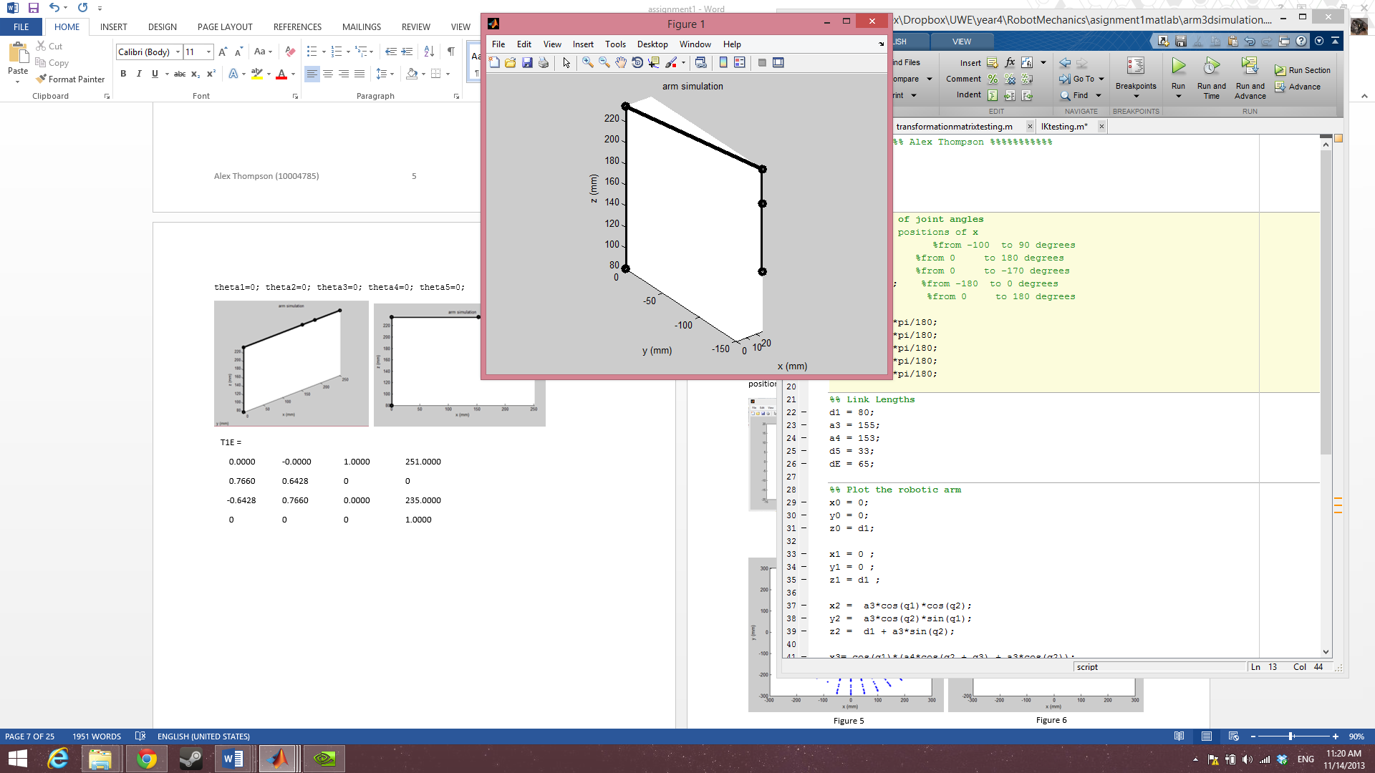 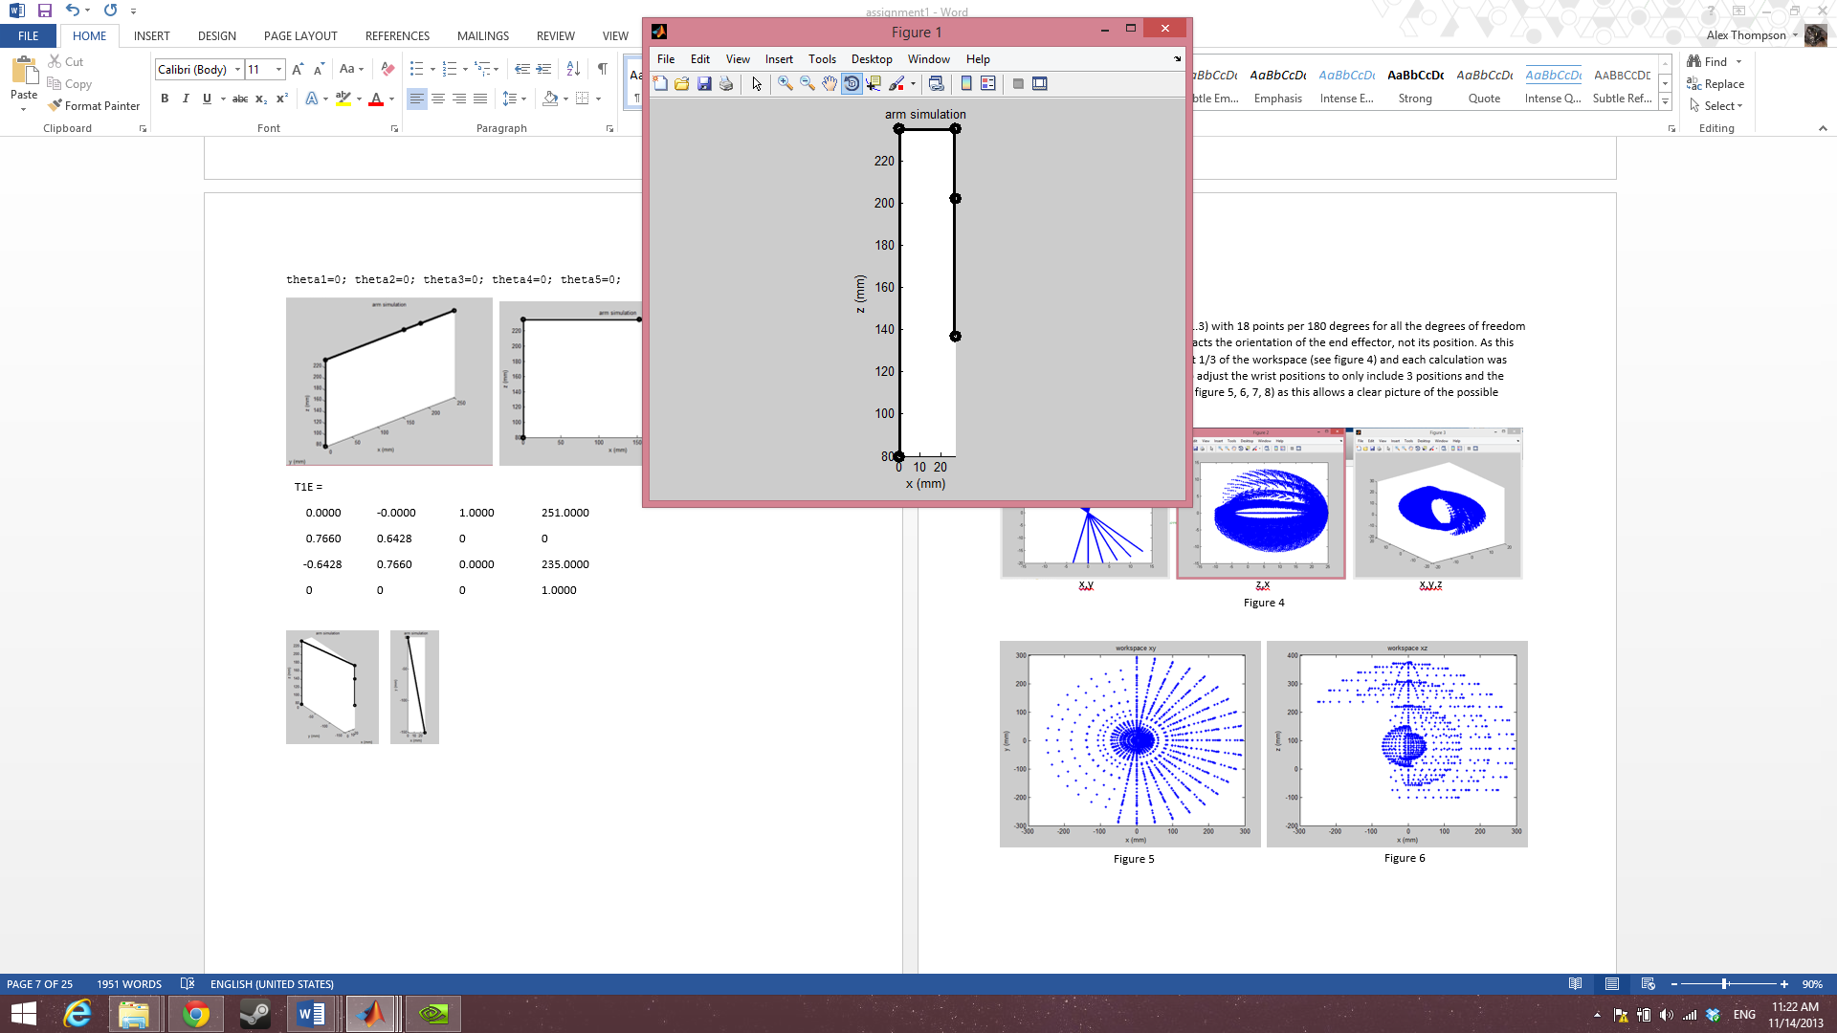 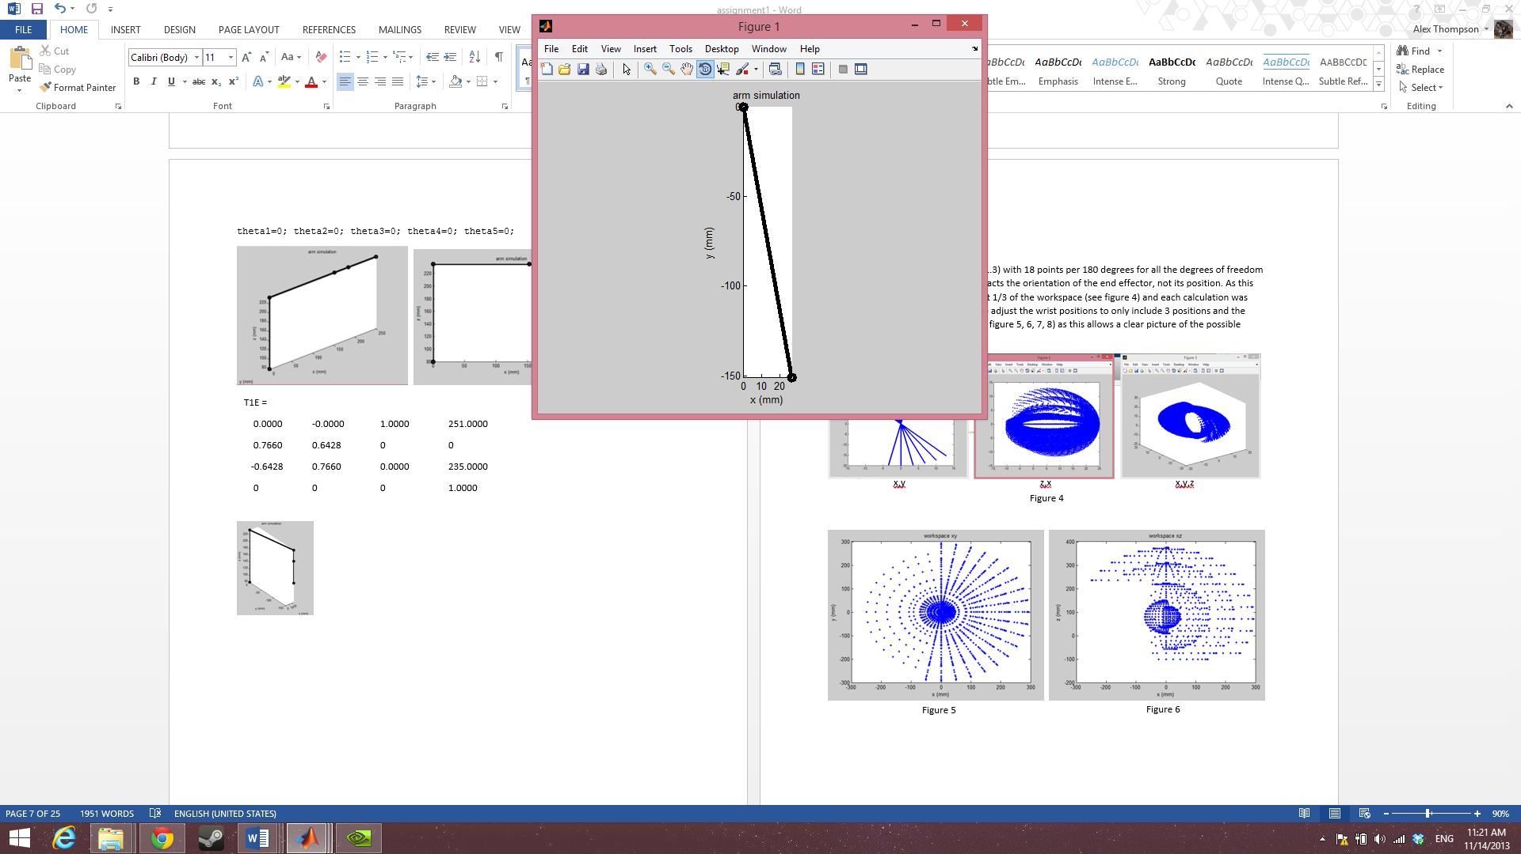

Figure 10

Figure 9

Figure 8

Figure 3

T1E =

0.6428 0.7660 0.0000 26.5682

0.7660 -0.6428 -0.0000 -150.6756

-0.0000 0.0000 -1.0000 137.0000

0 0 0 1.0000

## Workspace

### Matlab Approach

Initially I ran this code (see appendix 1.3) with 18 points per 180 degrees for all the degrees of freedom minus the rotation joint as it only impacts the orientation of the end effector, not its position. As this code took 11 hours to complete about 1/3 of the workspace (see figure 11) and each calculation was computed slightly slower, I decided to adjust the wrist positions to only include 3 positions and the elbow to only include 5 positions (see figure 12,13,14,15) as this allows a clear picture of the possible positions of the end effector while greatly reducing computation time.

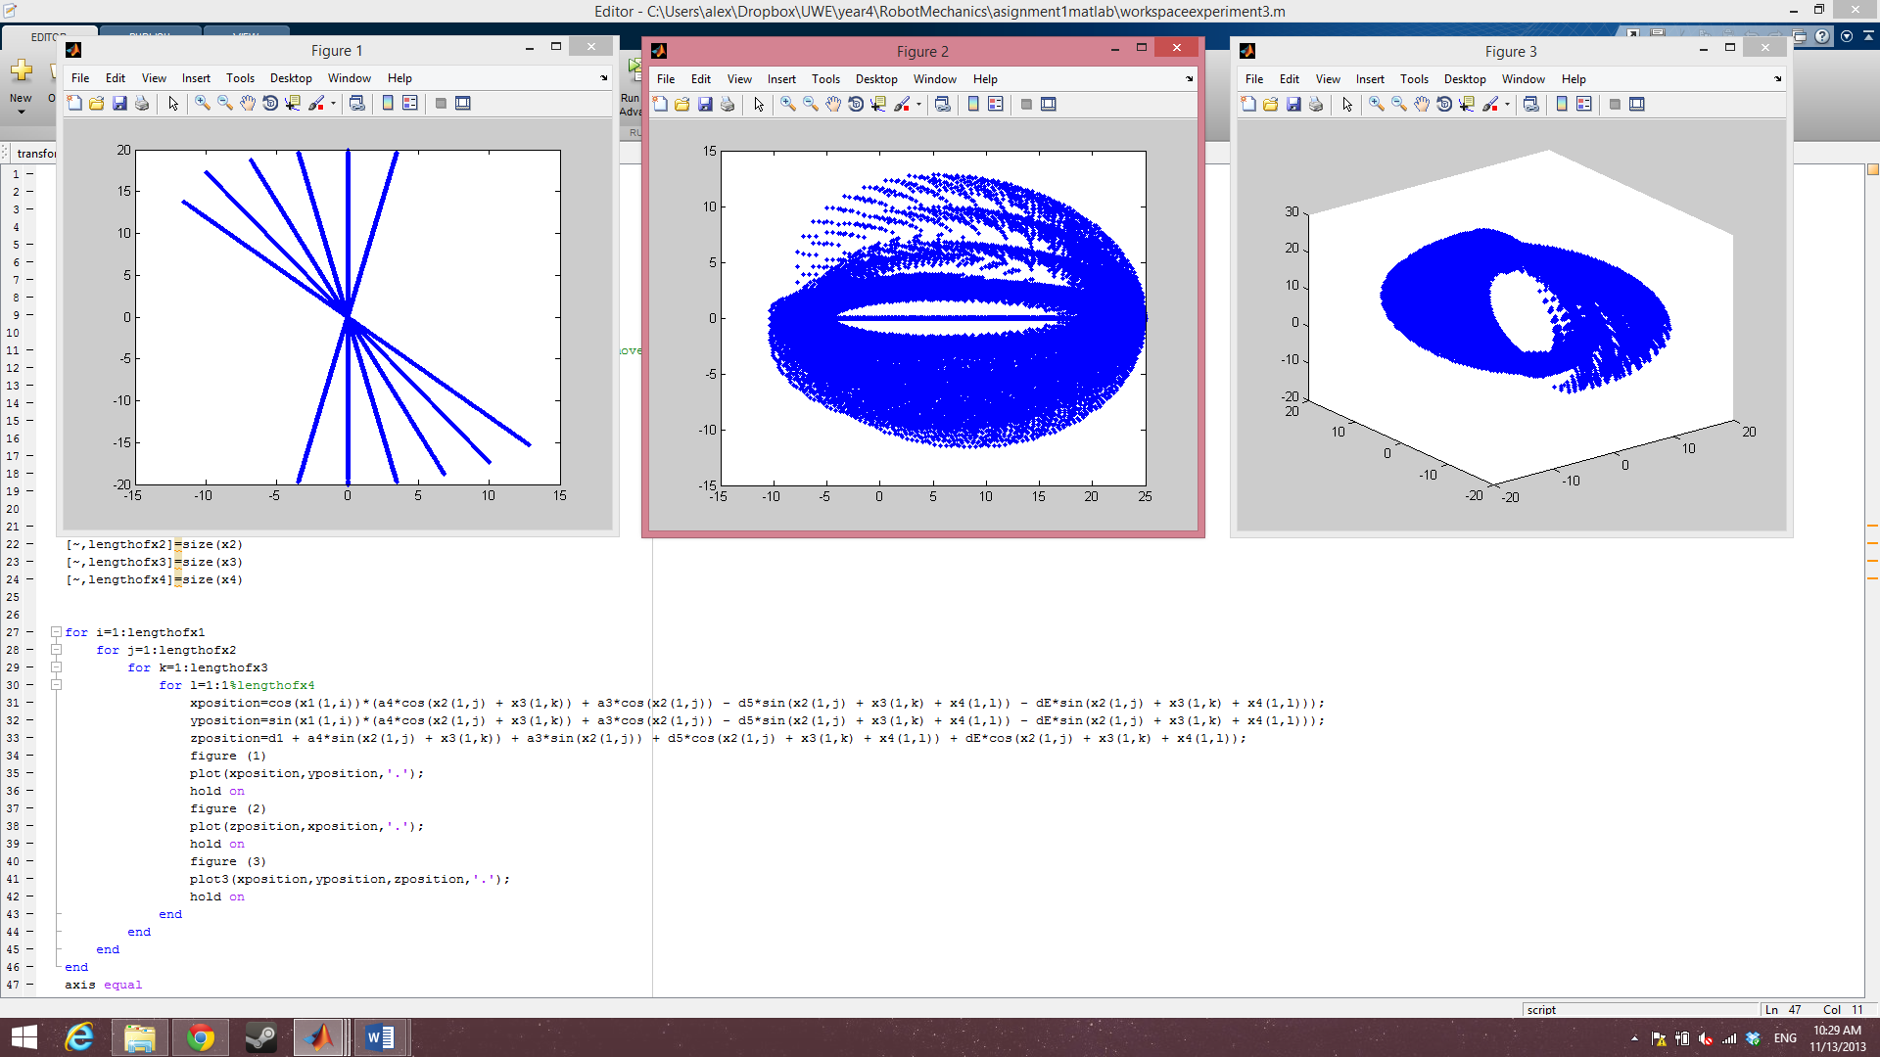

x,y

z,x

x,y,z

Figure 11

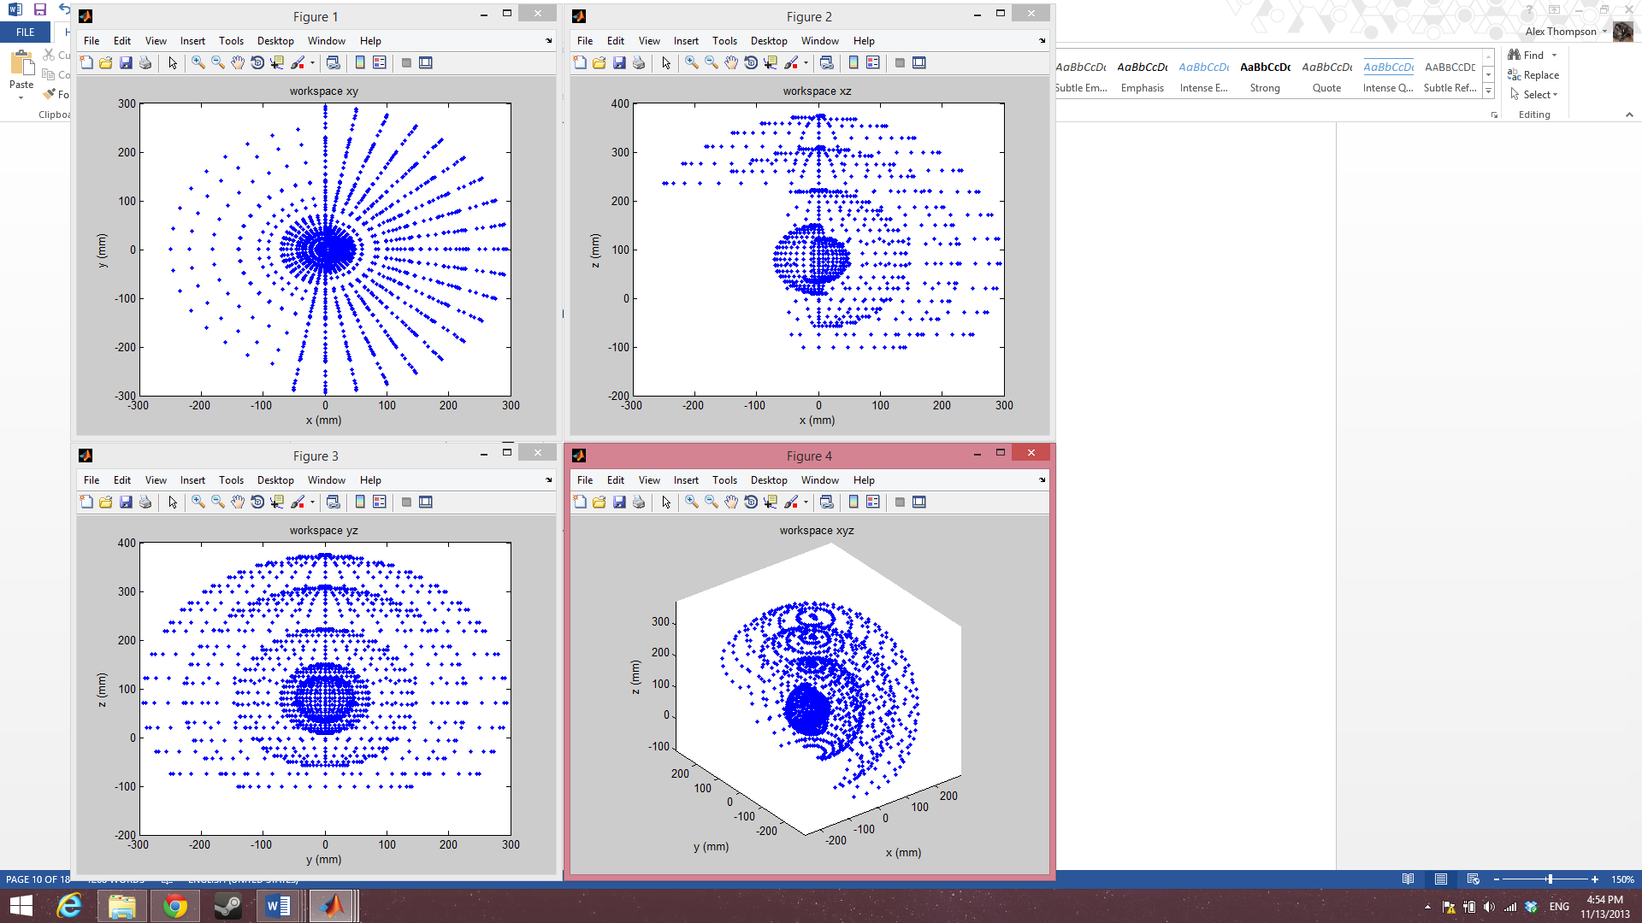 

Figure 13

Figure 12

 

Figure 15

Figure 14

### Geometric Approach

I also worked out the workspace geometrically by using circles with radius=link length to represent potential movement. The downside to this approach is that with every additional joint added the number of shapes needed to represent each movement increases exponentially. The end result of this effect is that this approach suffers from issues of granularity but it does allow a rough comparison to sanity check my Matlab calculations.

Top view if joint 2 is fixed

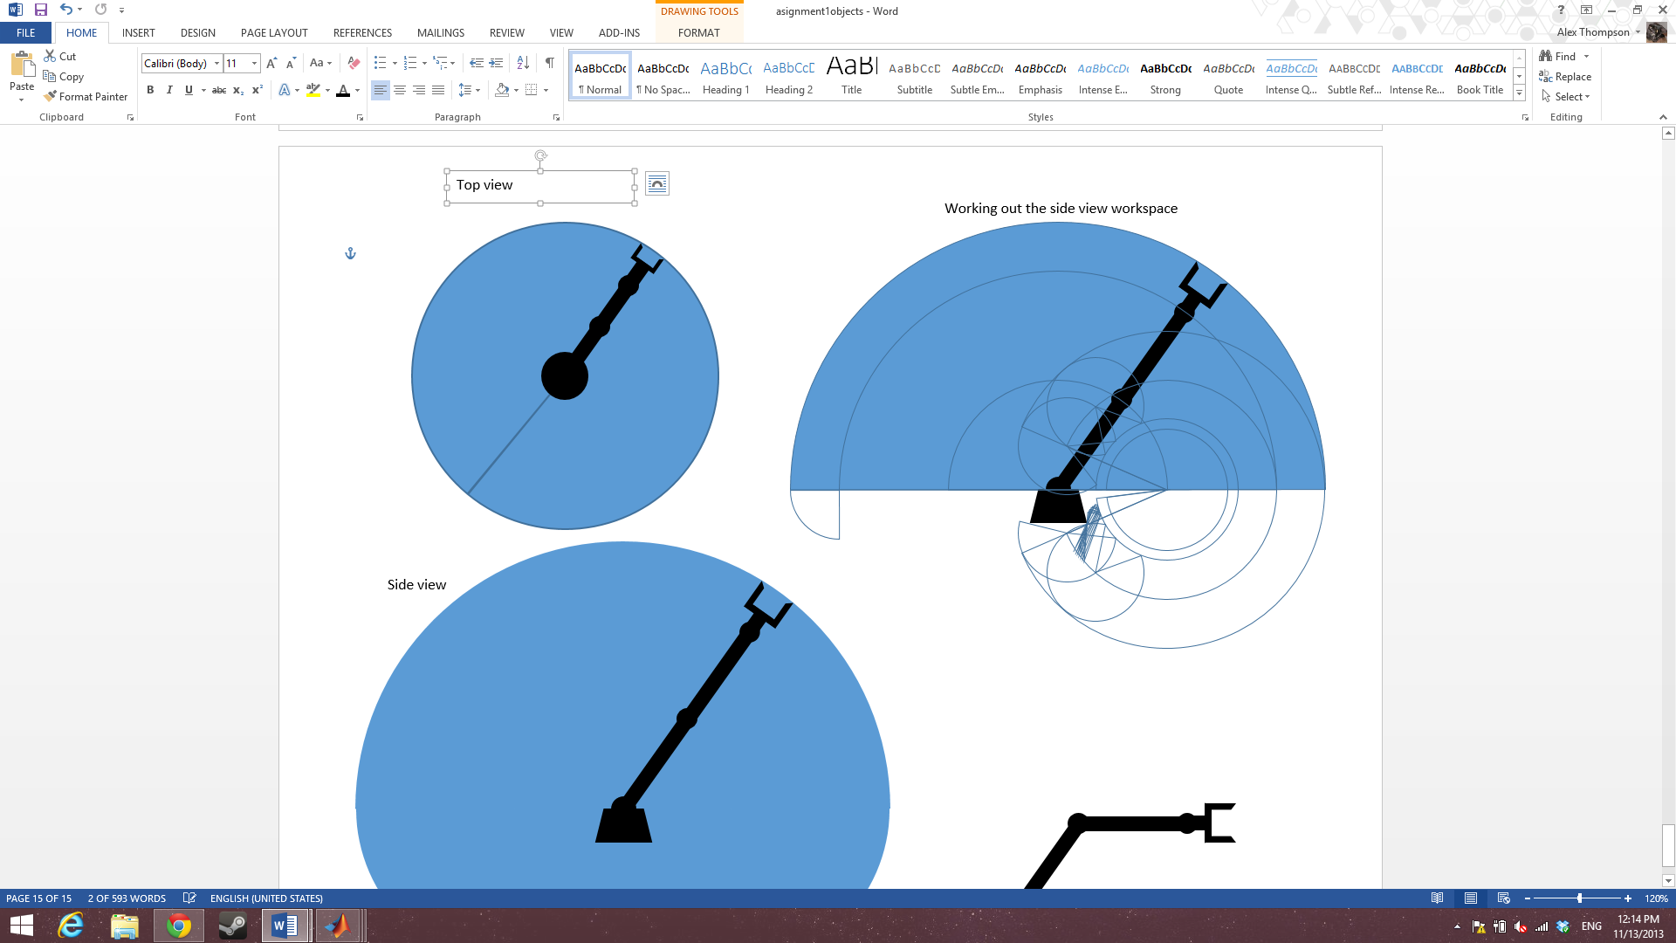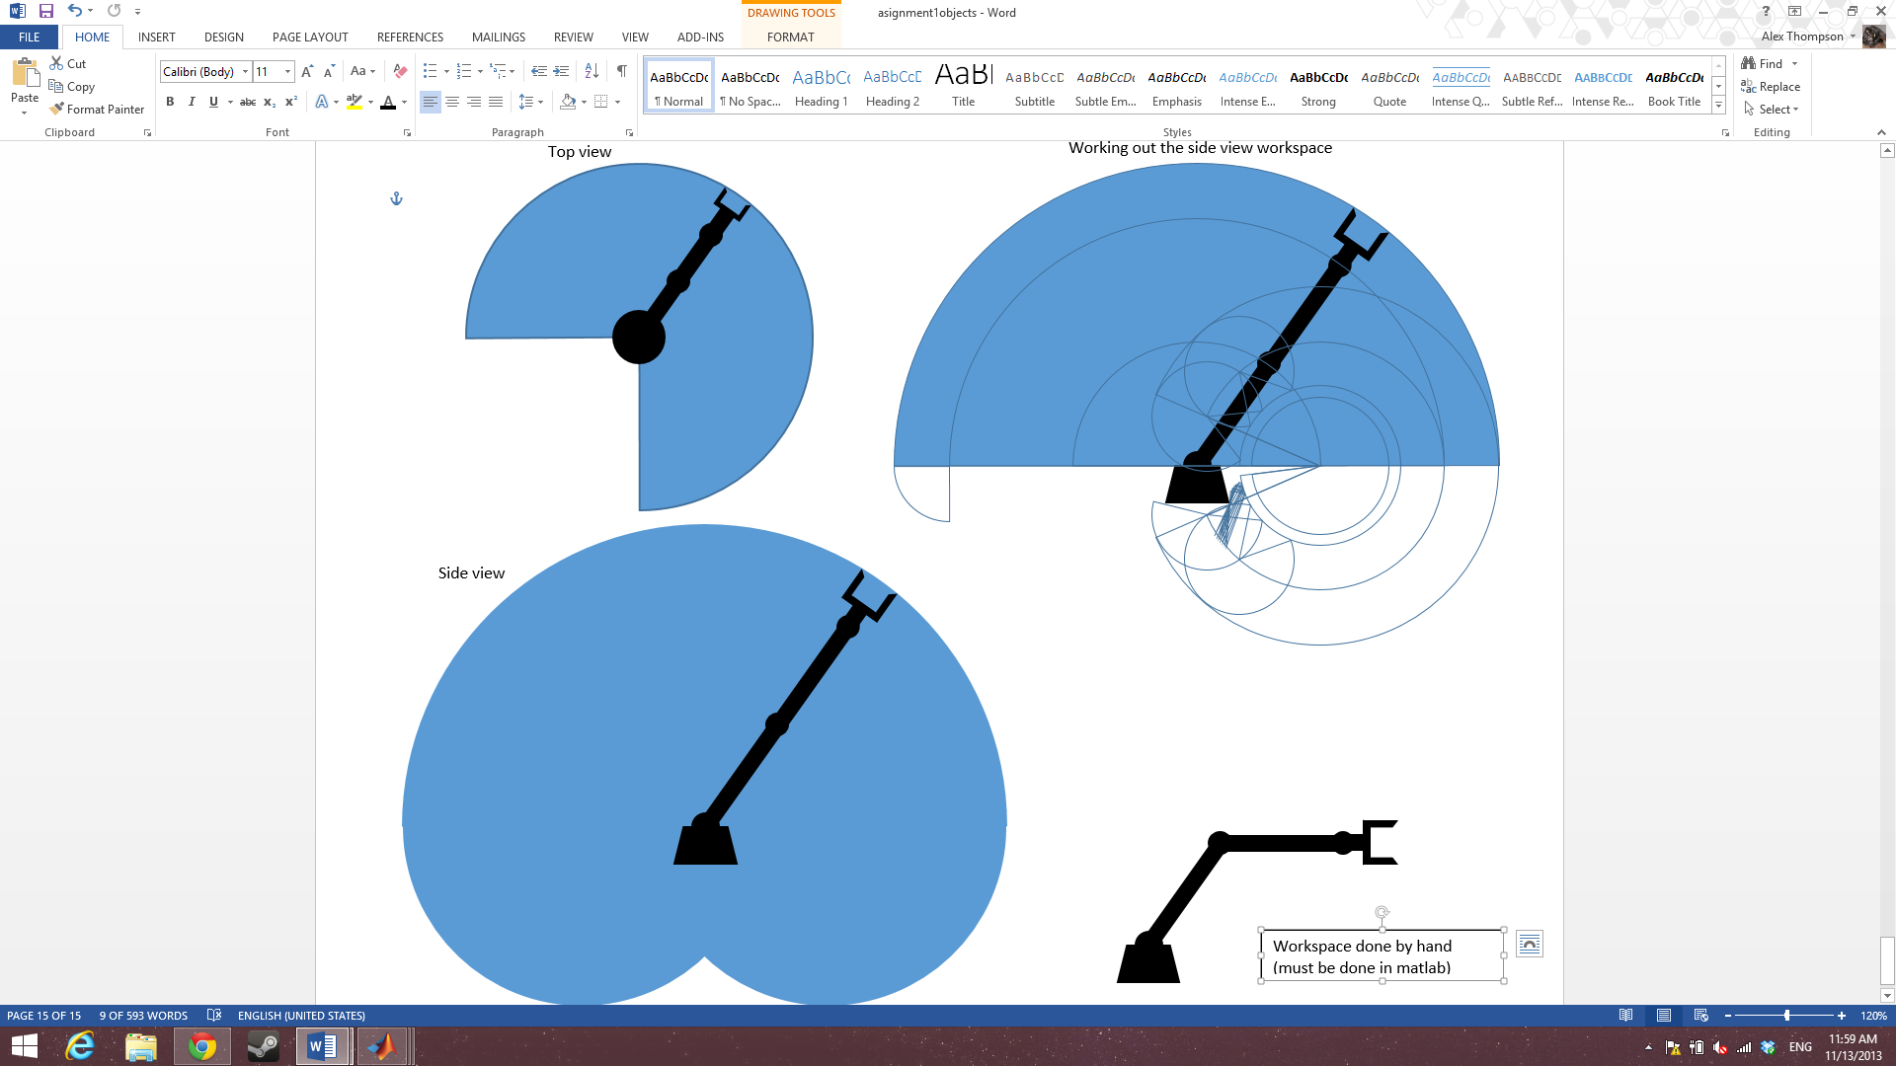

Figure 17

Figure 16

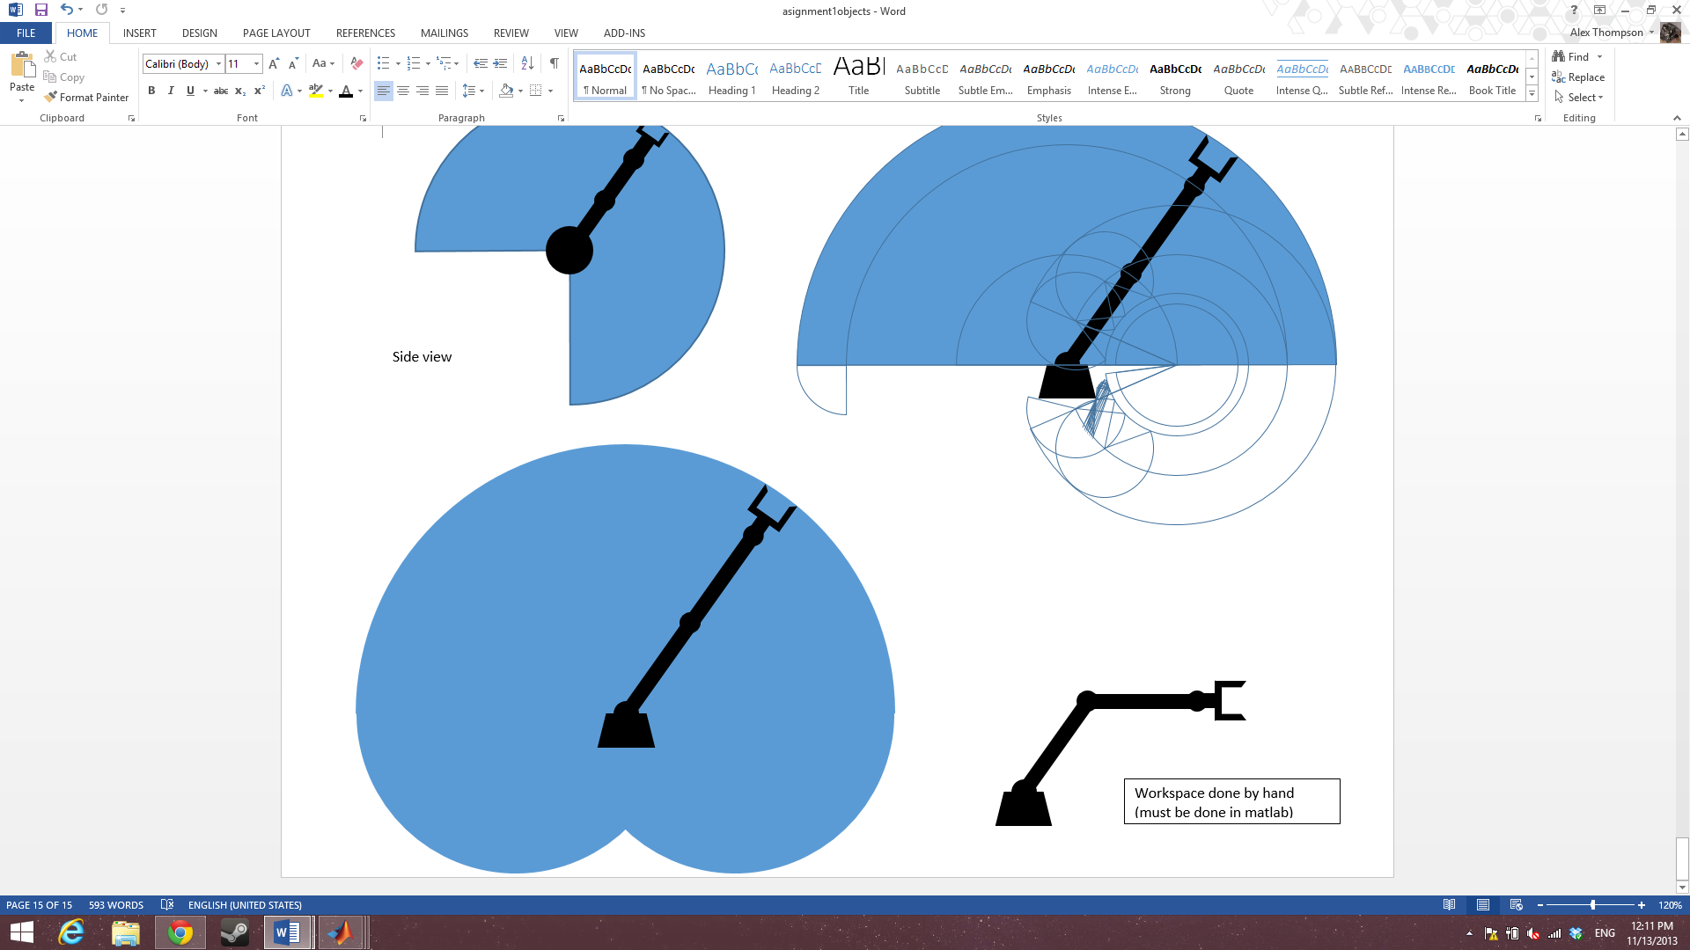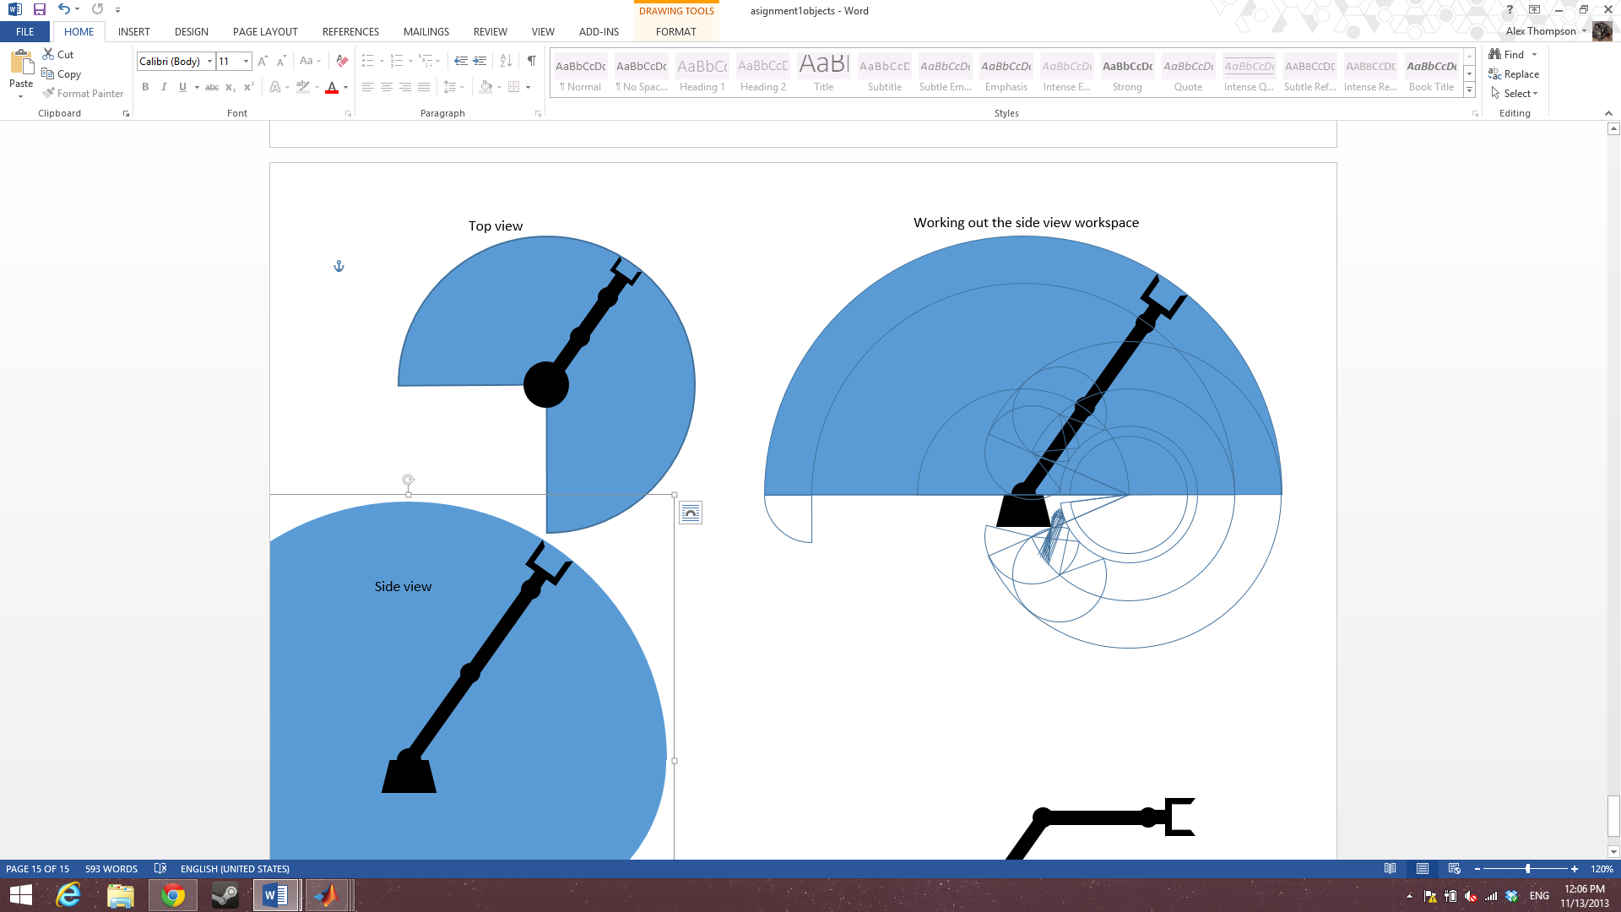

Figure 18

Working out the side view if joint 1 is unable to move

Full side view

Figure 19

## Inverse Kinematics

### Geometric Approach

See appendix 2.1 for trigonometric identities

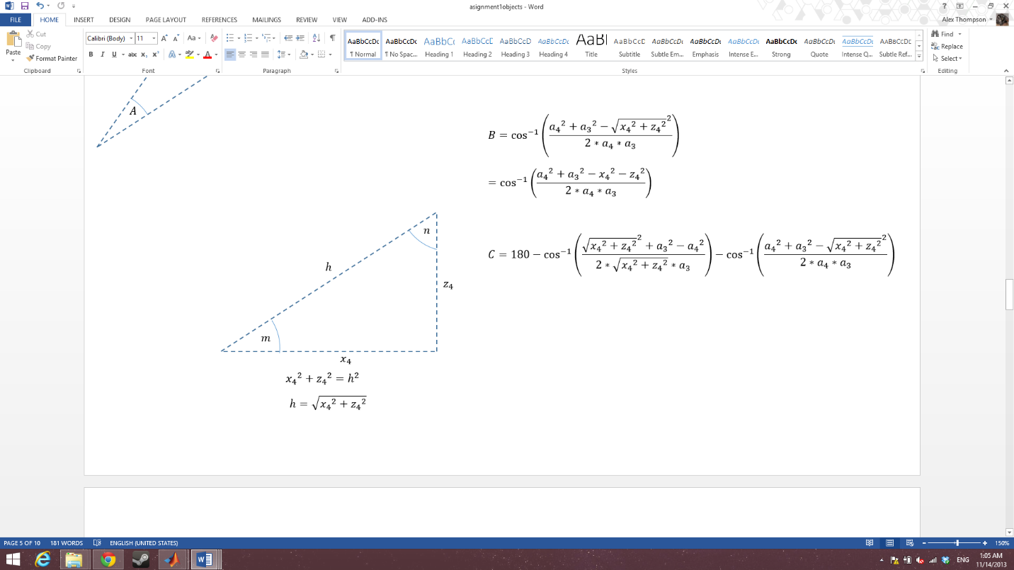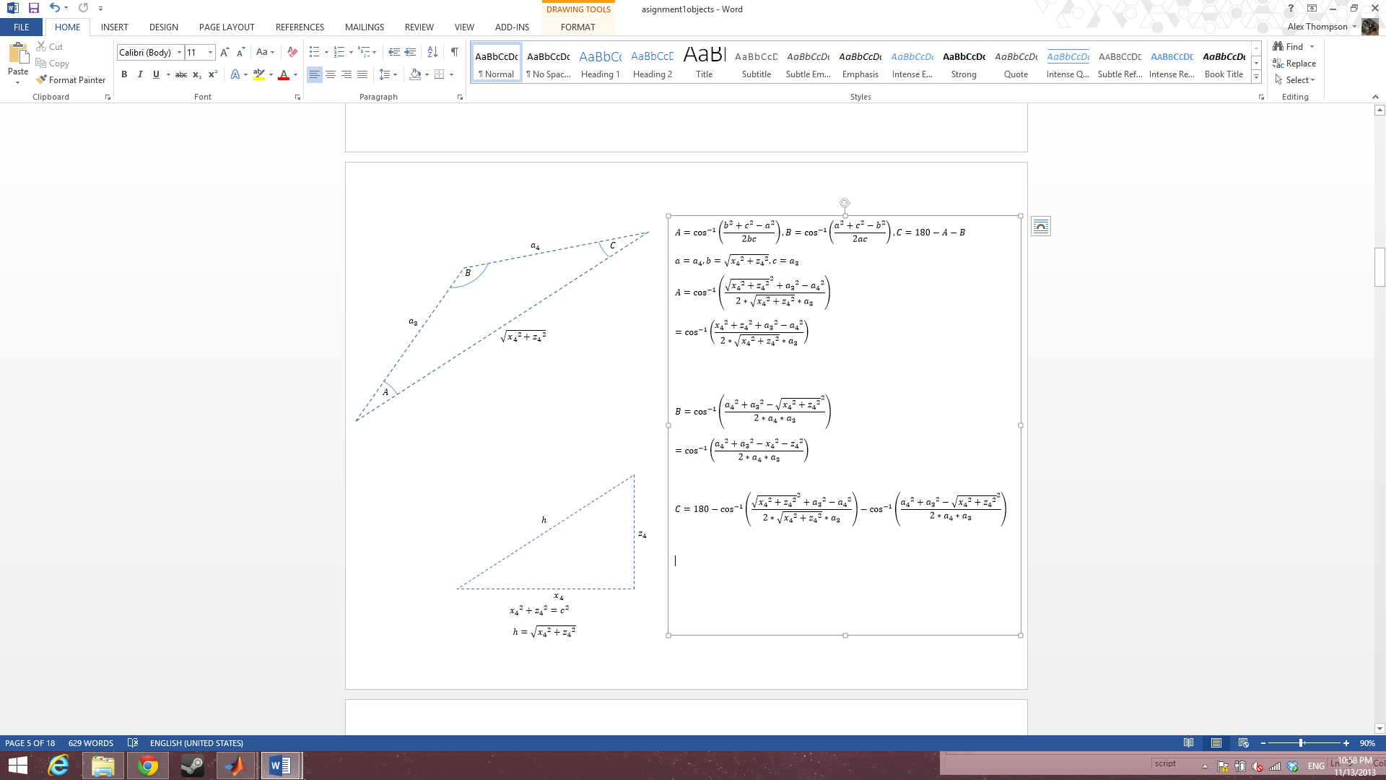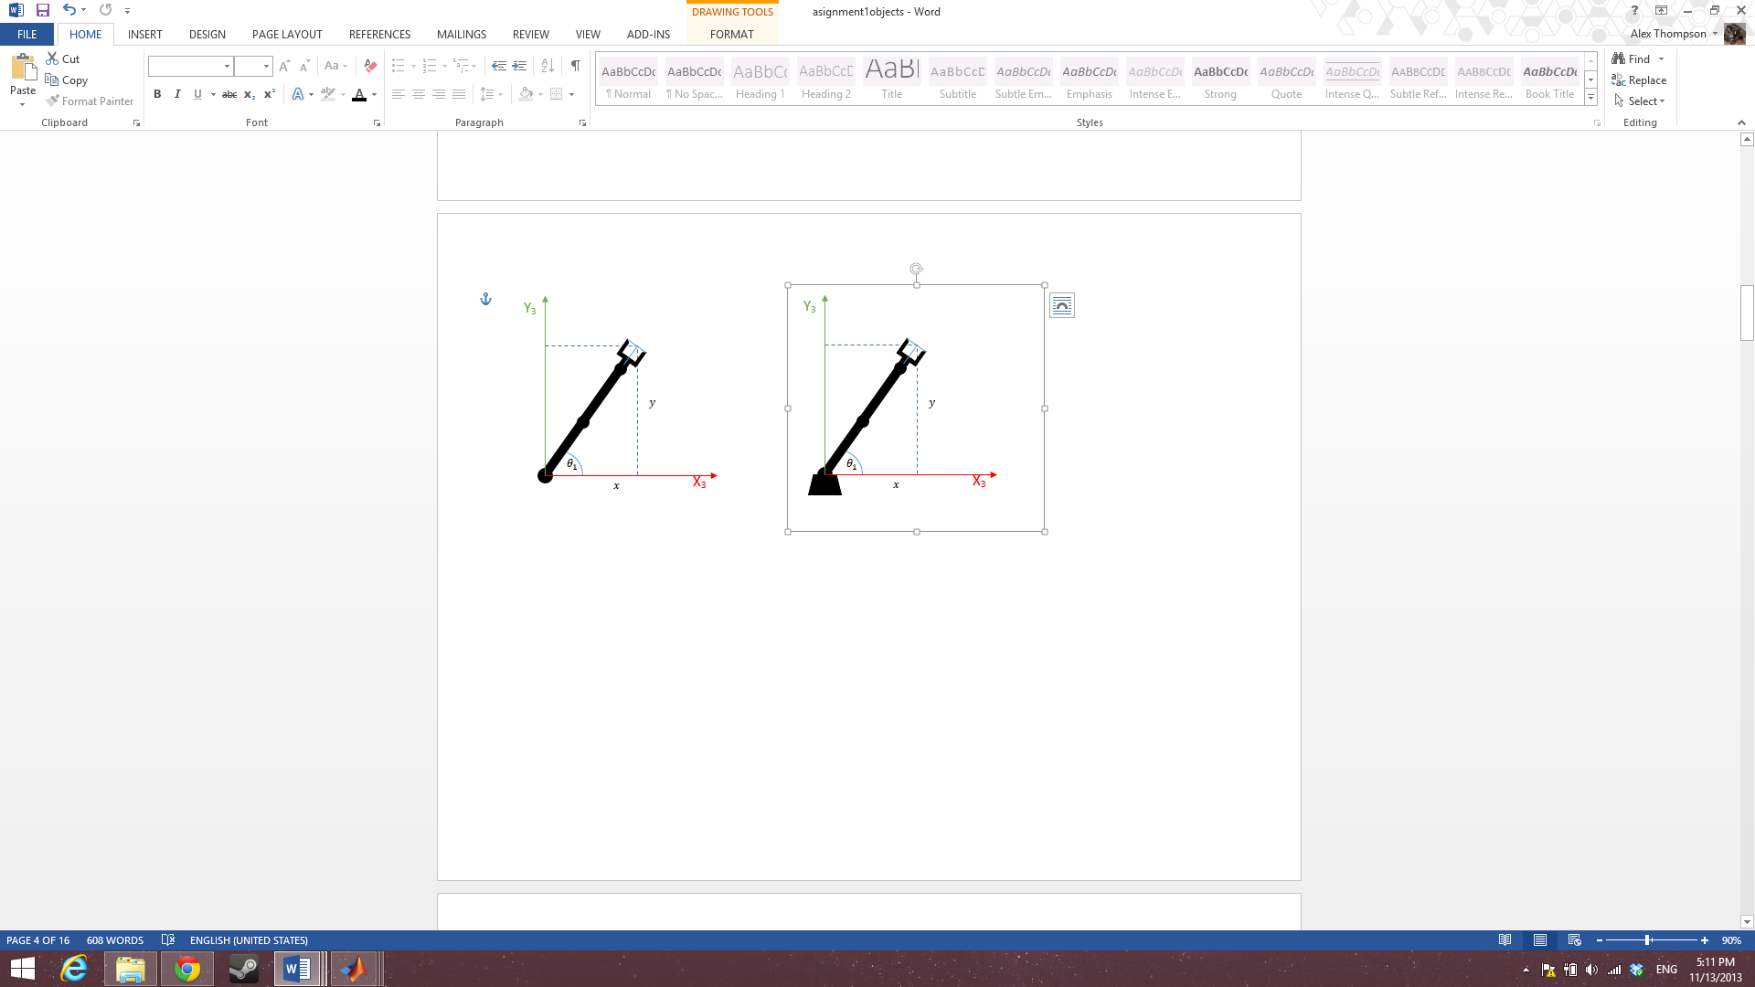

Figure 21

Figure 20

$$\tan{θ_{1}}=\frac{y}{x}$$

$$θ_{1}=\tan^{-1}\left(\frac{y}{x}\right)$$

Figure 22

Figure 23

$${x_{4}}^{2}+{z_{4}}^{2}=c^{2}$$

$$h=\sqrt{{x_{4}}^{2}+{z_{4}}^{2}}$$

$$m=\tan^{-1}\left(\frac{z_{4}}{x_{4}}\right)$$

$$n=\tan^{-1}\left(\frac{x_{4}}{z_{4}}\right)$$

$$a=a_{4}, b=\sqrt{{x_{4}}^{2}+{z_{4}}^{2}}, c=a_{3}$$

$$A=\cos^{-1}\left(\frac{{\sqrt{{x_{4}}^{2}+{z_{4}}^{2}}}^{2}+{a_{3}}^{2}-{a_{4}}^{2}}{2*\sqrt{{x_{4}}^{2}+{z_{4}}^{2}}*a_{3}}\right)$$

$$=\cos^{-1}\left(\frac{{x_{4}}^{2}+{z_{4}}^{2}+{a_{3}}^{2}-{a_{4}}^{2}}{2*\sqrt{{x_{4}}^{2}+{z_{4}}^{2}}*a_{3}}\right)$$

$$B=\cos^{-1}\left(\frac{{a_{4}}^{2}+{a_{3}}^{2}-{\sqrt{{x_{4}}^{2}+{z_{4}}^{2}}}^{2}}{2{*a}_{4}*a_{3}}\right)$$

$$=\cos^{-1}\left(\frac{{a_{4}}^{2}+{a_{3}}^{2}-{x_{4}}^{2}-{z_{4}}^{2}}{2{*a}_{4}*a_{3}}\right)$$

$$C=180-\cos^{-1}\left(\frac{{x_{4}}^{2}+{z_{4}}^{2}+{a_{3}}^{2}-{a_{4}}^{2}}{2*\sqrt{{x_{4}}^{2}+{z_{4}}^{2}}*a_{3}}\right)-\cos^{-1}\left(\frac{{a_{4}}^{2}+{a_{3}}^{2}-{x_{4}}^{2}-{z_{4}}^{2}}{2{*a}_{4}*a_{3}}\right)$$

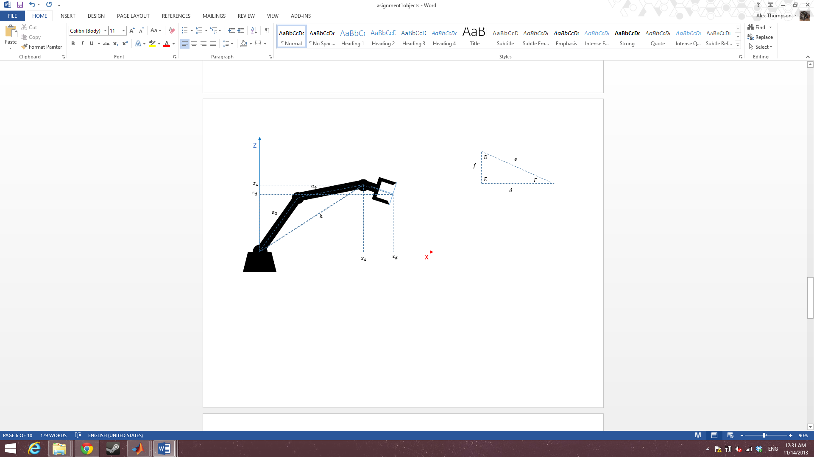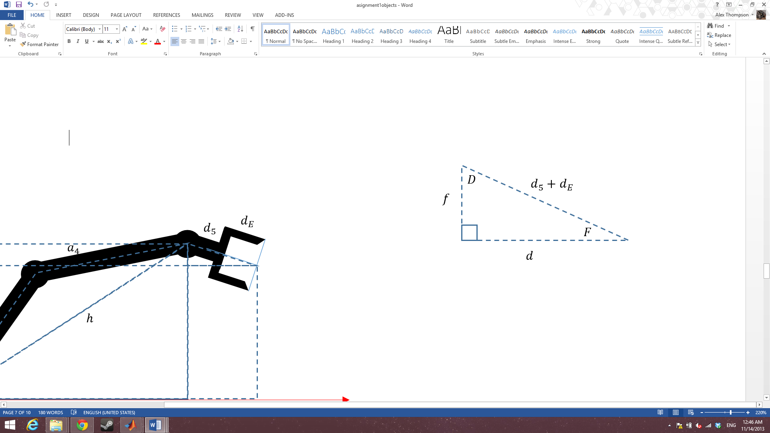

Figure 23

Figure 22

$$\sin{(F)}=\frac{f}{d_{5}+d_{E}}$$

$$f=\left(d_{5}+d_{E}\right)\sin{(F)}$$

$$\cos{(F)}=\frac{d}{d_{5}+d_{E}}$$

$$d=\left(d_{5}+d_{E}\right)\cos{(F)}$$

$$D=180-F-90=90-F$$

$$θ_{1}=\tan^{-1}\left(\frac{y}{x}\right)$$

$$θ_{2}=\cos^{-1}\left(\frac{{x_{4}}^{2}+{z_{4}}^{2}+{a_{3}}^{2}-{a_{4}}^{2}}{2*\sqrt{{x_{4}}^{2}+{z_{4}}^{2}}*a_{3}}\right)+\tan^{-1}\left(\frac{z_{4}}{x_{4}}\right)$$

$$θ_{3}=\cos^{-1}\left(\frac{{a_{4}}^{2}+{a_{3}}^{2}-{x_{4}}^{2}-{z_{4}}^{2}}{2{*a}_{4}*a_{3}}\right)$$

$$θ_{4}=C+\tan^{-1}\left(\frac{x_{4}}{z_{4}}\right)+90-F$$

T04 = (input matrix)*[(T4e)-1].

(T4e)-1= Te4 =(T45*T5e)-1

T04 =

[ cos(x2 + x3 + x4)*cos(x1), -sin(x2 + x3 + x4)*cos(x1), sin(x1), cos(x1)*(a4*cos(x2 + x3) + a3*cos(x2))]

[ cos(x2 + x3 + x4)*sin(x1), -sin(x2 + x3 + x4)*sin(x1), -cos(x1), sin(x1)*(a4*cos(x2 + x3) + a3*cos(x2))]

[ sin(x2 + x3 + x4), cos(x2 + x3 + x4), 0, d1 + a4*sin(x2 + x3) + a3*sin(x2)]

[ 0, 0, 0, 1]

T4E =

[ cos(x4), -sin(x4), 0, a4]

[ sin(x4), cos(x4), 0, 0]

[ 0, 0, 1, dE]

[ 0, 0, 0, 1]

TE4 =

[ cos(x4)/(cos(x4)^2 + sin(x4)^2), sin(x4)/(cos(x4)^2 + sin(x4)^2), 0, -(a4*cos(x4))/(cos(x4)^2 + sin(x4)^2)]

[ -sin(x4)/(cos(x4)^2 + sin(x4)^2), cos(x4)/(cos(x4)^2 + sin(x4)^2), 0, (a4*sin(x4))/(cos(x4)^2 + sin(x4)^2)]

[ 0, 0, 1, -dE]

[ 0, 0, 0, 1]

## Task

I have chosen to pick up an object from a horizontal handle on the side facing away from the robot and move the object to another location.

The order of operation for this task is:

Home position, above object, grasping object, above object, above goal, releasing object, above goal, home.

### Home position

Using FK: theta1=0; theta2=178; theta3=-150; theta4=-150; theta5=0;

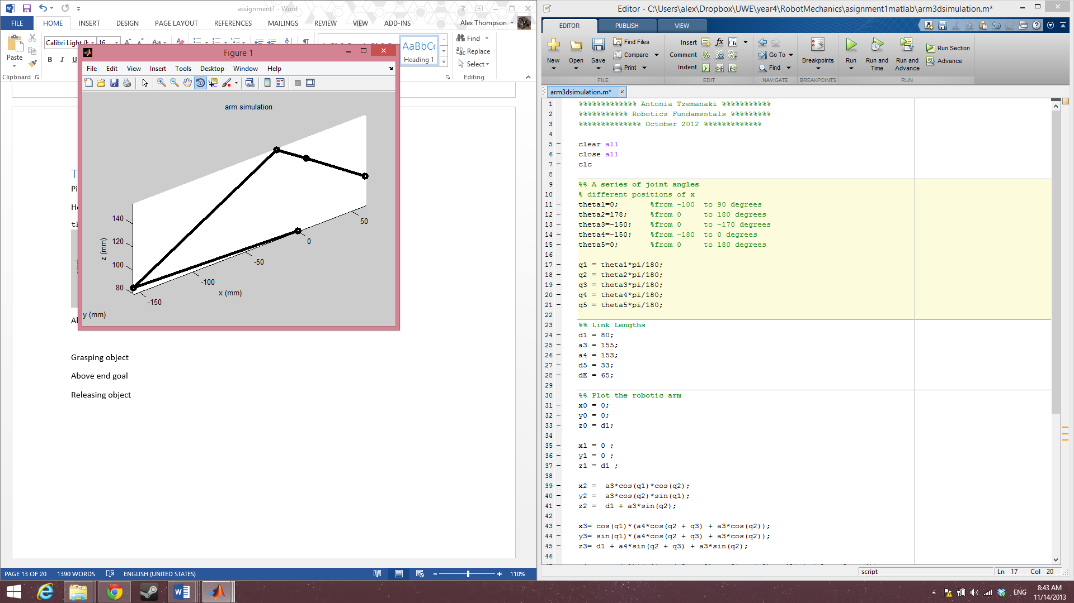 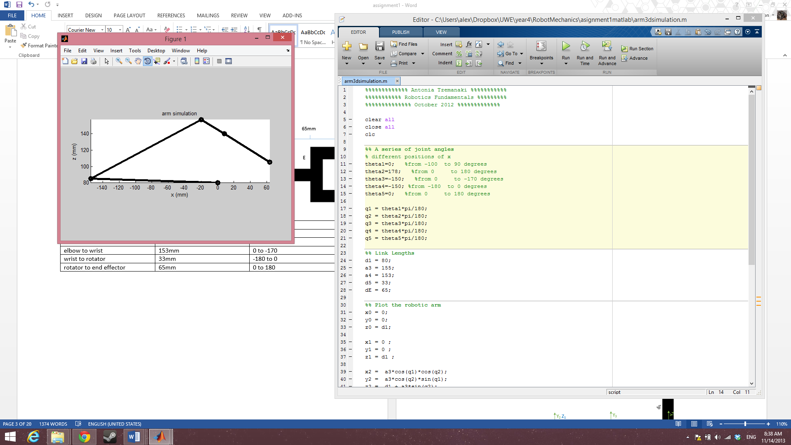

Figure 24

Figure 25

x = 63.2941

T1E =

-0.5299 0 0.8480 63.2941

0 1.0000 0 0

-0.8480 0 -0.5299 105.3065

0 0 0 1.0000

y = 0

z = 105.3065

Using IK:

$$θ_{1}=\tan^{-1}\left(\frac{0}{63.2941}\right)=0$$

### Above object

Using FK: theta1=30; theta2=78; theta3=-78; theta4=-180; theta5=0;

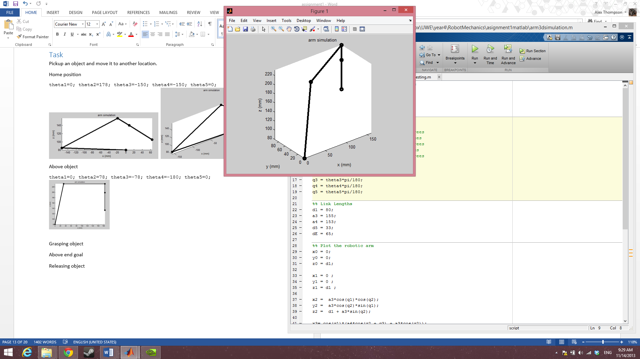 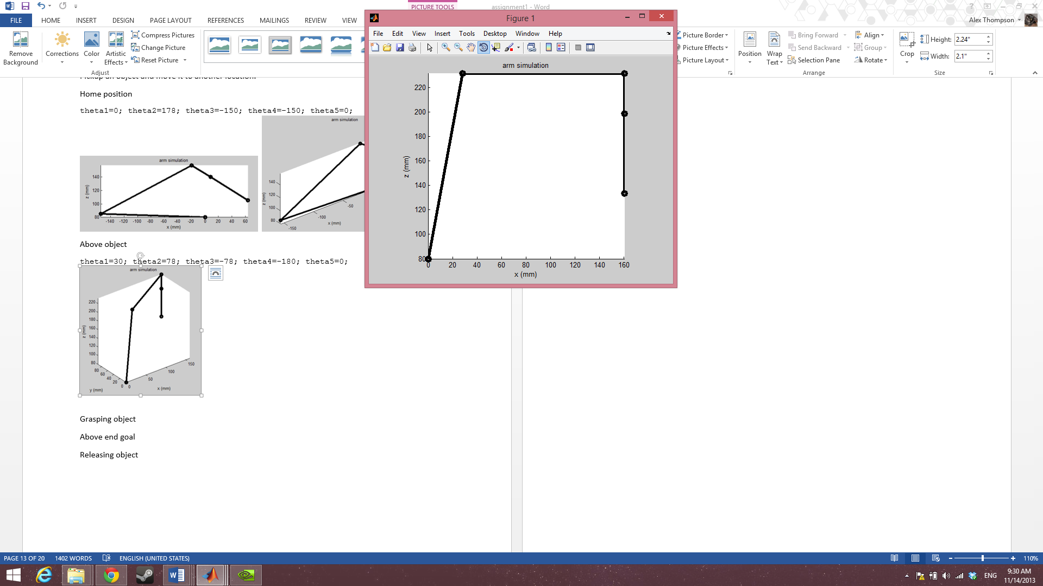

Figure 26

Figure 27

end effector position:

T1E =

-0.8660 -0.5000 0.0000 160.4107

-0.5000 0.8660 0.0000 92.6132

-0.0000 0 -1.0000 133.6129

0 0 0 1.0000

x = 160.4107

y = 92.6132

z = 133.6129

Using IK:

$$θ_{1}=\tan^{-1}\left(\frac{92.6132}{160.4107}\right)=0.5236$$

$$\frac{0.5236*180}{pi}=30.0001 note, an error of 0.0001 appears from rounding the above answer$$

### Grasping object

Using FK: theta1=30; theta2=58; theta3=-78; theta4=-180; theta5=0;

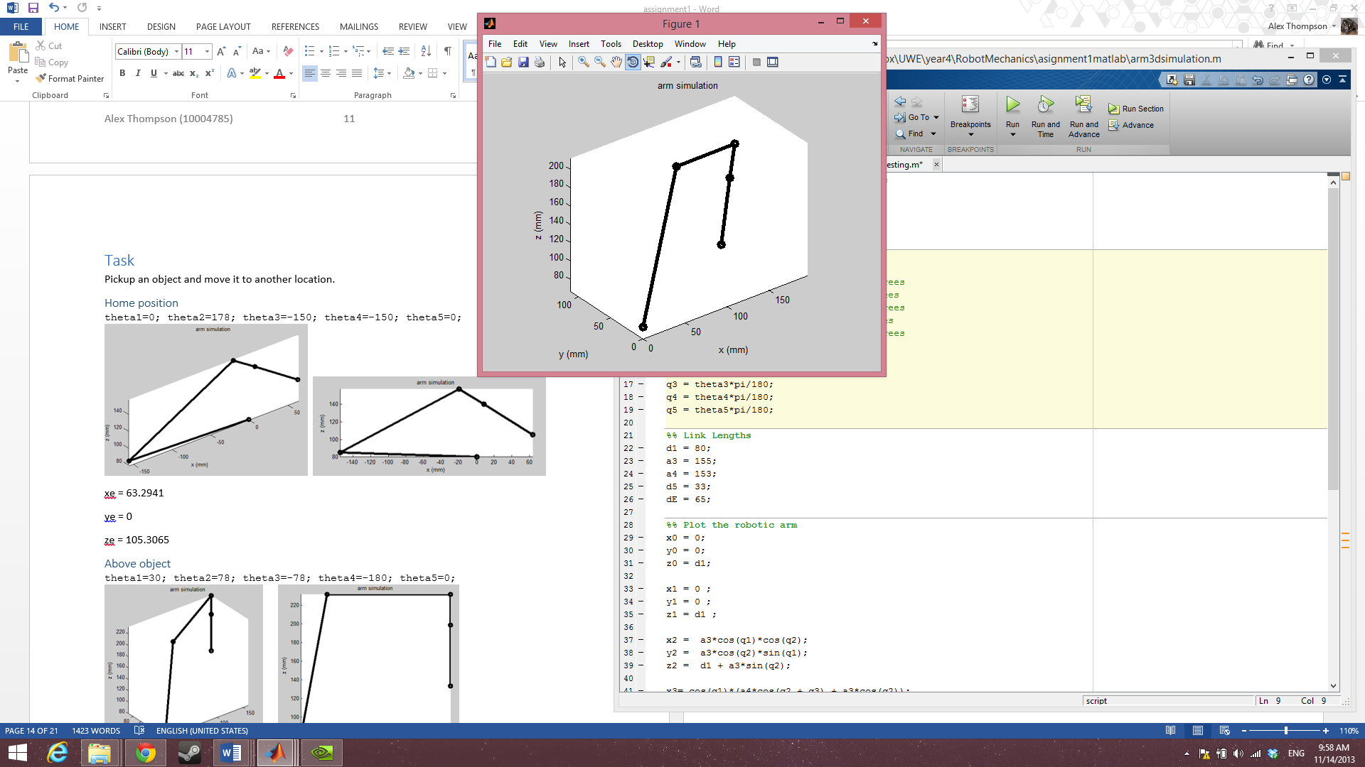 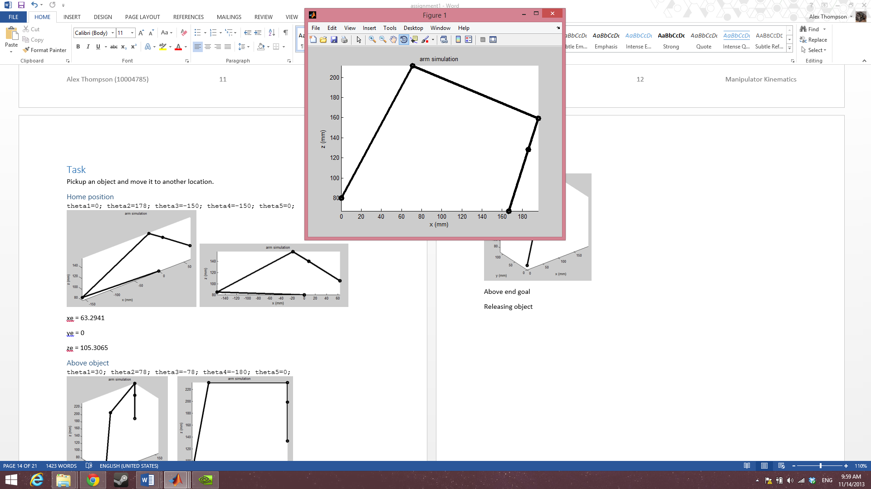

Figure 29

Figure 28

T1E =

-0.8138 -0.5000 -0.2962 166.6168

-0.4698 0.8660 -0.1710 96.1962

0.3420 0 -0.9397 67.0285

0 0 0 1.0000

end effector position:

x = 166.6168

y = 96.1962

z = 67.0285

Using IK:

$$θ_{1}=\tan^{-1}\left(\frac{96.1962}{166.6168}\right)= 0.5236$$

$$\frac{ 0.5236*180}{pi}=30.0001$$

### Above end goal

Using FK: theta1=-40; theta2=78; theta3=-78; theta4=-180; theta5=0;

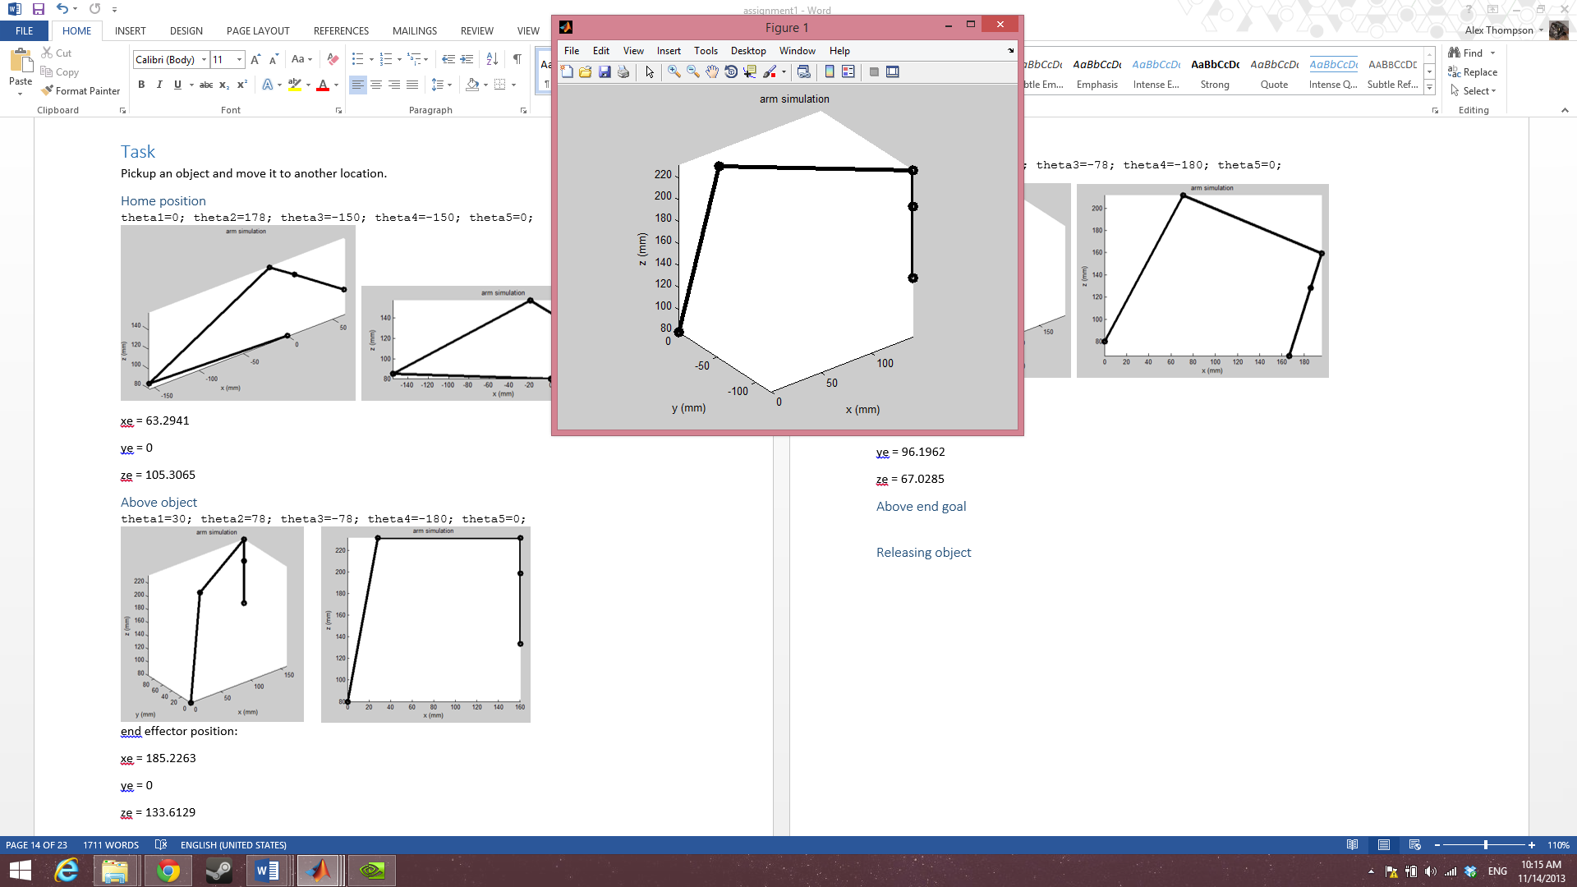 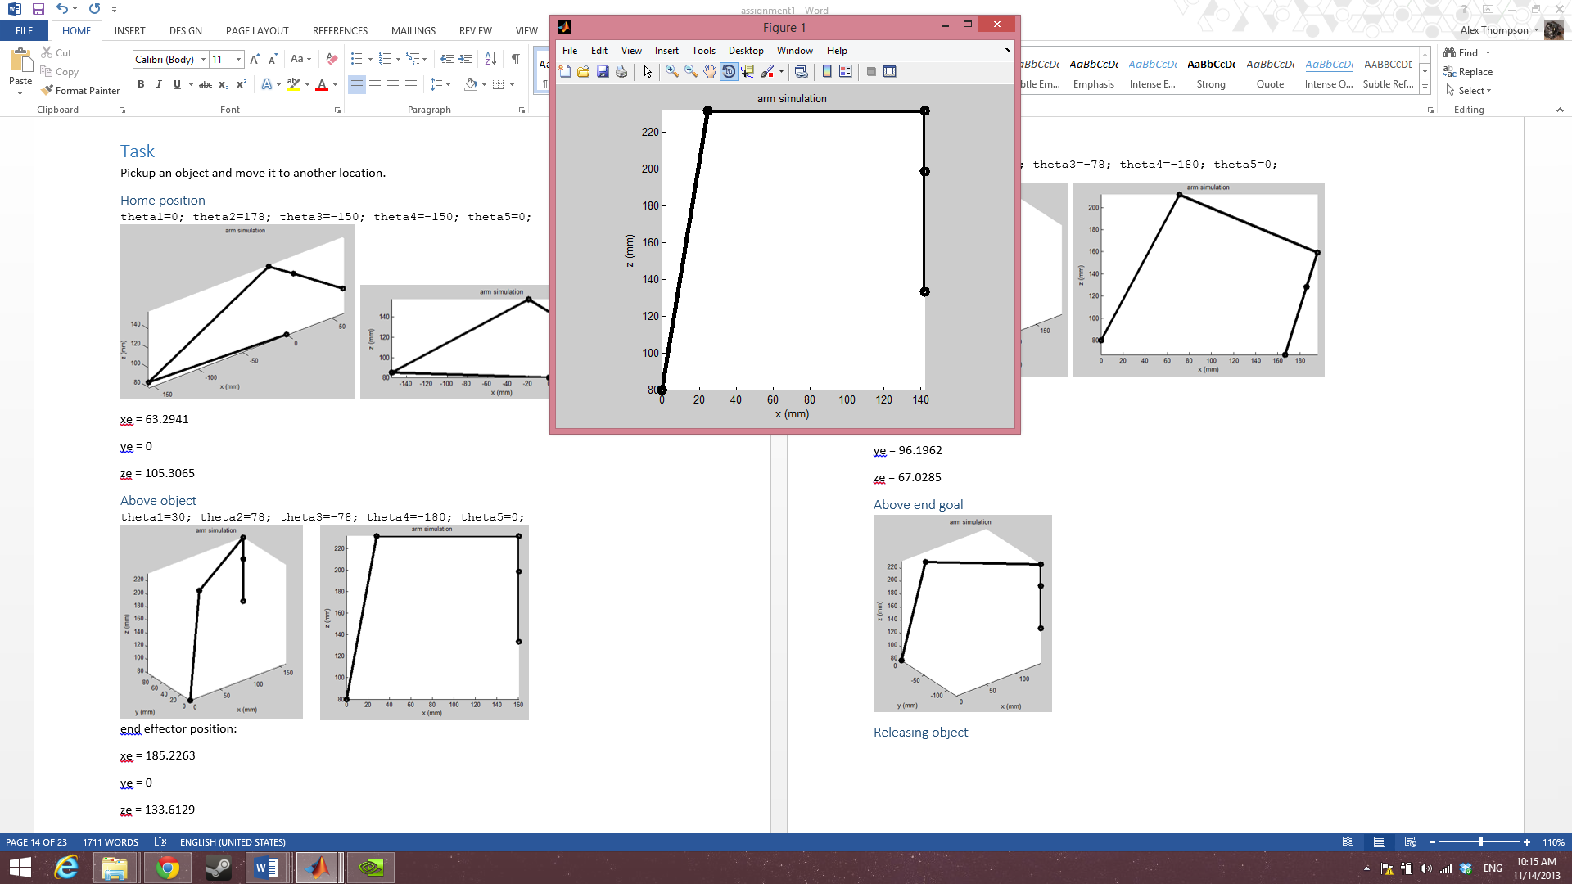

Figure 30

Figure 31

T1E =

-0.7660 0.6428 0.0000 141.8916

0.6428 0.7660 -0.0000 -119.0612

-0.0000 0 -1.0000 133.6129

0 0 0 1.0000

x = 141.8916

y = -119.0612

z = 133.6129

Using IK:

$$θ_{1}=\tan^{-1}\left(\frac{-119.0612}{141.8916}\right)=-0.6981$$

$$\frac{-0.6981*180}{pi}=-39.9982$$

### Releasing object

Using FK: theta1=-40; theta2=58; theta3=-78; theta4=-180; theta5=0;

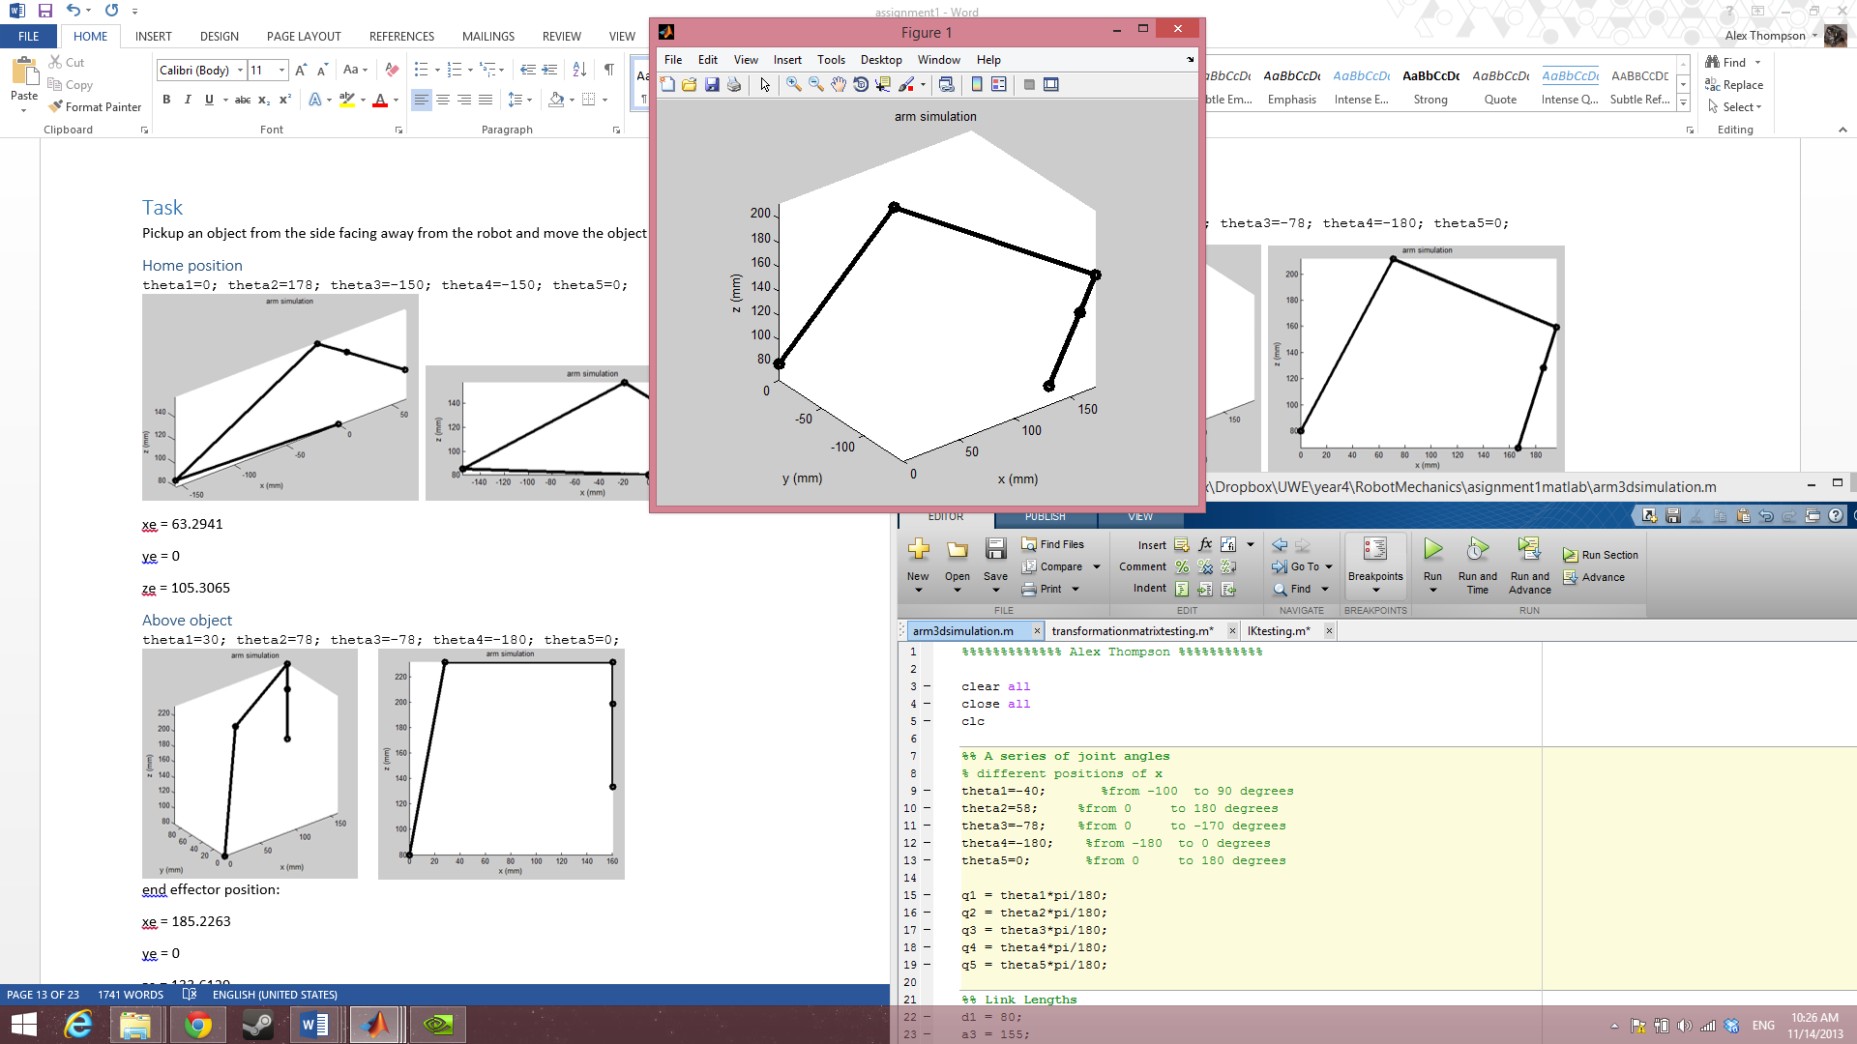 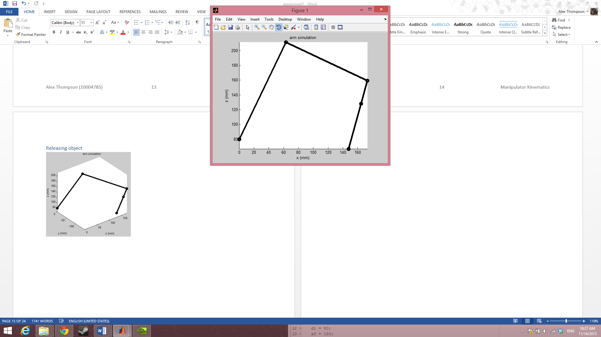

Figure 32

Figure 33

x = 147.3812

T1E =

-0.7198 0.6428 -0.2620 147.3812

0.6040 0.7660 0.2198 -123.6675

0.3420 0 -0.9397 67.0285

0 0 0 1.0000

y = -123.6675

z = 67.0285

Using IK:

$$θ_{1}=\tan^{-1}\left(\frac{-123.6675}{147.3812}\right)=-0.6981$$

$$\frac{-0.6981 *180}{pi}=-39.9982$$

## Kinematics Summary

From this assignment I have found that the best method for determining the transformation matrices based on the DH table is to use the generalized equation. I have found that while the easiest method to map the workspace is the geometric approach, it suffers from issues of accuracy for every additional joint of the robot and so it is better to plot the workspace in Matlab using the end effector positions obtained from the forward kinematics. For solving the inverse kinematics I came across two possible methods (algebraic and geometric). I decided to go with geometric as visualizing the problem helped me to break the problem down.

# Intelligence

2 joints, anfis

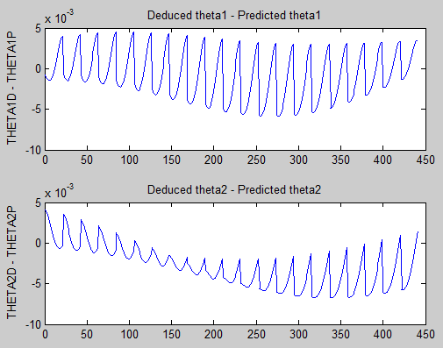

first network done in 16.239 seconds

second network done in 9.025 seconds

2 joints, genfis

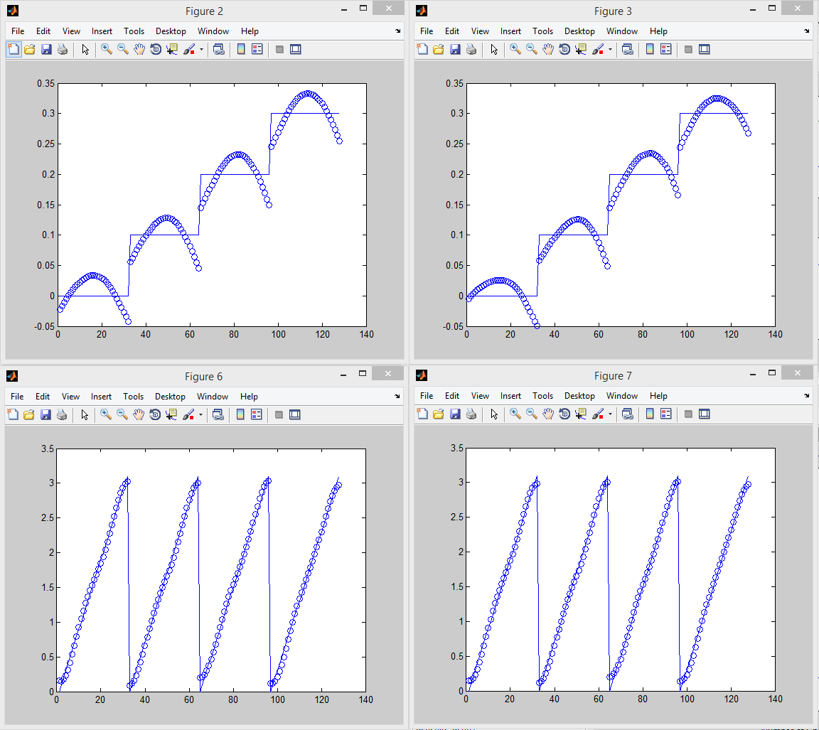

first network done in 1.752 seconds

second network done in 2.302 seconds

# Expansion

## GUI Arm Simulation

## Machine Vision System

# Appendix

## Matlab Code

note, all Matlab code based on work by Antonia Tzemanaki (Tzemanaki, n.d.)

### 1.1 Solving T1E Using Matlab:

syms x1 x2 x3 x4 x5 a3 a4 d1 d5 dE

T1=[cos(x1) –sin(x1) 0 0;sin(x1) cos(x1) 0 0;0 0 1 d1;0 0 0 1];

T2=[cos(x2) –sin(x2) 0 0;0 0 -1 0;sin(x2) cos(x2) 0 0;0 0 0 1];

T3=[cos(x3) –sin(x3) 0 a3;sin(x3) cos(x3) 0 0;0 0 1 0;0 0 0 1];

T4=[cos(x4) –sin(x4) 0 a4;sin(x4) cos(x4) 0 0;0 0 1 0;0 0 0 1];

T5=[cos(x5) –sin(x5) 0 0;0 0 1 d5;-sin(x5) -cos(x5) 0 0;0 0 0 1];

TE=[1 0 0 0; 0 1 0 0;0 0 1 dE;0 0 0 1];

T1E=simplify(T1*T2*T3*T4*T5*TE);

Output is

[ cos(x2 + x3 + x4)*cos(x1)*cos(x5) - sin(x1)*sin(x5), - cos(x5)*sin(x1) - cos(x2 + x3 + x4)*cos(x1)*sin(x5), -sin(x2 + x3 + x4)*cos(x1), cos(x1)*(a4*cos(x2 + x3) + a3*cos(x2) - d5*sin(x2 + x3 + x4) - dE*sin(x2 + x3 + x4))]

[ cos(x1)*sin(x5) + cos(x2 + x3 + x4)*cos(x5)*sin(x1), cos(x1)*cos(x5) - cos(x2 + x3 + x4)*sin(x1)*sin(x5), -sin(x2 + x3 + x4)*sin(x1), sin(x1)*(a4*cos(x2 + x3) + a3*cos(x2) - d5*sin(x2 + x3 + x4) - dE*sin(x2 + x3 + x4))]

[ sin(x2 + x3 + x4)*cos(x5), -sin(x2 + x3 + x4)*sin(x5), cos(x2 + x3 + x4), d1 + a4*sin(x2 + x3) + a3*sin(x2) + d5*cos(x2 + x3 + x4) + dE*cos(x2 + x3 + x4)]

[ 0, 0, 0, 1]

### 1.2 Testing the Forward Kinematics

theta1=-80; %from -100 to 90 degrees

theta2=90; %from 0 to 180 degrees

theta3=-90; %from 0 to -170 degrees

theta4=-180; %from -180 to 0 degrees

theta5=50; %from 0 to 180 degrees

x1 = theta1*pi/180;

x2 = theta2*pi/180;

x3 = theta3*pi/180;

x4 = theta4*pi/180;

x5 = theta5*pi/180;

d1=80;

a3=155;

a4=153;

d5=33;

dE=65;

T1=[cos(x1) –sin(x1) 0 0;sin(x1) cos(x1) 0 0;0 0 1 d1;0 0 0 1];

T2=[cos(x2) –sin(x2) 0 0;0 0 -1 0;sin(x2) cos(x2) 0 0;0 0 0 1];

T3=[cos(x3) –sin(x3) 0 a3;sin(x3) cos(x3) 0 0;0 0 1 0;0 0 0 1];

T4=[cos(x4) –sin(x4) 0 a4;sin(x4) cos(x4) 0 0;0 0 1 0;0 0 0 1];

T5=[cos(x5) –sin(x5) 0 0;0 0 1 d5;-sin(x5) -cos(x5) 0 0;0 0 0 1];

TE=[cos(xE) –sin(xE) 0 0; sin(xE) cos(xE) 0 0;0 0 1 dE;0 0 0 1];

T1E= T1*T2*T3*T4*T5*TE;

Output is

T1E =

0.0000 0 -1.0000 -71.0000

0 1.0000 0 0

1.0000 0 0.0000 317.0000

0 0 0 1.0000

### 1.3 Calculating the workspace

clear all

close all

clc

d1=80;

a3=155;

a4=153;

d5=33;

dE=65;

x1=(-100*pi)/180:pi/18:pi/2; %from -100 to 90 degrees with an increment size of pi/18

x2=0:pi/18:pi; %from 0 to 180 degrees with an increment size of pi/18

x3=-pi+((10*pi)/180):pi/5:0; %from 0 to -170 degrees with an increment size of pi/5

x4=-pi:pi/2:0; %from -180 to 0 degrees with an increment size of pi/2

x5=0; %set to 0 as its rotation won’t affect the position of

%the end effector, just its orientation.

xposition=zeros(360,360);

yposition=zeros(360,360);

zposition=zeros(360,360);

[~,lengthofx1]=size(x1);

[~,lengthofx2]=size(x2);

[~,lengthofx3]=size(x3);

[~,lengthofx4]=size(x4);

for i=1:lengthofx1

for j=1:lengthofx2

for k=1:lengthofx3

for l=1:1%lengthofx4

xposition=cos(x1(1,i))*(a4*cos(x2(1,j) + x3(1,k)) + a3*cos(x2(1,j)) - d5*sin(x2(1,j) + x3(1,k) + x4(1,l)) - dE*sin(x2(1,j) + x3(1,k) + x4(1,l)));

yposition=sin(x1(1,i))*(a4*cos(x2(1,j) + x3(1,k)) + a3*cos(x2(1,j)) - d5*sin(x2(1,j) + x3(1,k) + x4(1,l)) - dE*sin(x2(1,j) + x3(1,k) + x4(1,l)));

zposition=d1 + a4*sin(x2(1,j) + x3(1,k)) + a3*sin(x2(1,j)) + d5*cos(x2(1,j) + x3(1,k) + x4(1,l)) + dE*cos(x2(1,j) + x3(1,k) + x4(1,l));

figure (1)

plot(xposition,yposition,'.');

hold on

title('workspace xy') ; xlabel('x (mm)') ; ylabel('y (mm)'); zlabel('z (mm)') ;

figure (2)

plot(xposition,zposition,'.');

hold on

title('workspace xz') ; xlabel('x (mm)') ; ylabel('z (mm)');

figure (3)

plot(yposition,zposition,'.');

hold on

title('workspace yz') ; xlabel('y (mm)') ; ylabel('z (mm)');

figure (4)

plot3(xposition,yposition,zposition,'.');

hold on

title('workspace xyz') ; xlabel('x (mm)') ; ylabel('y (mm)'); zlabel('z (mm)') ;

end

end

end

end

axis equal

### 1.4 Simulating the Arm

%%%%%%%%%%%%% Alex Thompson %%%%%%%%%%%

clear all

close all

clc

%% A series of joint angles

% different positions of x

theta1=30; %from -100 to 90 degrees

theta2=58; %from 0 to 180 degrees

theta3=-78; %from 0 to -170 degrees

theta4=-180; %from -180 to 0 degrees

theta5=0; %from 0 to 180 degrees

q1 = theta1*pi/180;

q2 = theta2*pi/180;

q3 = theta3*pi/180;

q4 = theta4*pi/180;

q5 = theta5*pi/180;

%% Link Lengths

d1 = 80;

a3 = 155;

a4 = 153;

d5 = 33;

dE = 65;

%% Plot the robotic arm

x0 = 0;

y0 = 0;

z0 = d1;

x1 = 0 ;

y1 = 0 ;

z1 = d1 ;

x2 = a3*cos(q1)*cos(q2);

y2 = a3*cos(q2)*sin(q1);

z2 = d1 + a3*sin(q2);

x3= cos(q1)*(a4*cos(q2 + q3) + a3*cos(q2));

y3= sin(q1)*(a4*cos(q2 + q3) + a3*cos(q2));

z3= d1 + a4*sin(q2 + q3) + a3*sin(q2);

x4 = cos(q1)*(a4*cos(q2 + q3) + a3*cos(q2) - d5*sin(q2 + q3 + q4));

y4 = sin(q1)*(a4*cos(q2 + q3) + a3*cos(q2) - d5*sin(q2 + q3 + q4));

z4 = d1 + a4*sin(q2 + q3) + a3*sin(q2) + d5*cos(q2 + q3 + q4);

xe = cos(q1)*(a4*cos(q2 + q3) + a3*cos(q2) - (d5+dE)*sin(q2 + q3 + q4))

ye = sin(q1)*(a4*cos(q2 + q3) + a3*cos(q2) - (d5+dE)*sin(q2 + q3 + q4))

ze = d1 + a4*sin(q2 + q3) + a3*sin(q2) + (d5+dE)*cos(q2 + q3 + q4)

i=1;

xx = [ x0(i); x1(i); x2(i); x3(i); x4(i); xe(i) ];

yy = [ y0(i); y1(i); y2(i); y3(i); y4(i); ye(i) ];

zz = [ z0(i); z1(i); z2(i); z3(i); z4(i); ze(i) ];

plot3(xx,yy,zz,'ko-','Linewidth',4)

axis equal

hold on

title('arm simulation'); xlabel('x (mm)') ; ylabel('y (mm)'); zlabel('z (mm)');

### 1.5 Testing Inverse Kinematics

d1=0;

a3=155;

a4=153;

d5=33;

dE=65;

x4=185; %needs to be fixed when xd is determined

z4=133+(d5+dE)-d1; %needs to be fixed when zd is determined

C=180-acos((x4^2+z4^2+a3^2-a4^2)/(2*a3*sqrt(x4^2+z4^2+a3)))-acos((a4^2+a3^2-x4^2-z4^2)/(2*a4*a3));

theta2=acos((x4^2+z4^2+a3^2-a4^2)/(2*a3*sqrt(x4^2+z4^2+a3)))+atan(z4/x4);

theta3=acos((a4^2+a3^2-x4^2-z4^2)/(2*a4*a3));

%theta4=C+atan(x4/z4)+90-F

theta2*180/pi

theta3*180/pi

## 2.0 Math

### 2.1 Trigonometric Identities

laws of cosines (math.com, 2005)

$$A=\cos^{-1}\left(\frac{b^{2}+c^{2}-a^{2}}{2bc}\right)$$

$$B=\cos^{-1}\left(\frac{a^{2}+c^{2}-b^{2}}{2ac}\right)$$

$$C=180-A-B$$

### 2.2 Forward kinematics

- sin(x1)*sin(x5) - cos(x5)*(cos(x4)*(cos(x1)*sin(x2)*sin(x3) - cos(x1)*cos(x2)*cos(x3)) + sin(x4)*(cos(x1)*cos(x2)*sin(x3) + cos(x1)*cos(x3)*sin(x2)))=**cos(x2 + x3 + x4)*cos(x1)*cos(x5) - sin(x1)*sin(x5)**

$r_{12}=$ sin(x5)*(cos(x4)*(cos(x1)*sin(x2)*sin(x3) - cos(x1)*cos(x2)*cos(x3)) + sin(x4)*(cos(x1)*cos(x2)*sin(x3) + cos(x1)*cos(x3)*sin(x2))) - cos(x5)*sin(x1)=**- cos(x5)*sin(x1) - cos(x2 + x3 + x4)*cos(x1)*sin(x5)**

$r_{13}=$ sin(x4)*(cos(x1)*sin(x2)*sin(x3) - cos(x1)*cos(x2)*cos(x3)) - cos(x4)*(cos(x1)*cos(x2)*sin(x3) + cos(x1)*cos(x3)*sin(x2))=**-sin(x2 + x3 + x4)*cos(x1)**

$p_{x}=$ a3*cos(x1)*cos(x2) - d5*(cos(x4)*(cos(x1)*cos(x2)*sin(x3) + cos(x1)*cos(x3)*sin(x2)) - sin(x4)*(cos(x1)*sin(x2)*sin(x3) - cos(x1)*cos(x2)*cos(x3))) - dE*(cos(x4)*(cos(x1)*cos(x2)*sin(x3) + cos(x1)*cos(x3)*sin(x2)) - sin(x4)*(cos(x1)*sin(x2)*sin(x3) - cos(x1)*cos(x2)*cos(x3))) - a4*(cos(x1)*sin(x2)*sin(x3) - cos(x1)*cos(x2)*cos(x3))=**cos(x1)*(a4*cos(x2 + x3) + a3*cos(x2) - d5*sin(x2 + x3 + x4) - dE*sin(x2 + x3 + x4))**

$r_{21}=$ cos(x5)*(cos(x4)*(cos(x2)*cos(x3)*sin(x1) - sin(x1)*sin(x2)*sin(x3)) - sin(x4)*(cos(x2)*sin(x1)*sin(x3) + cos(x3)*sin(x1)*sin(x2))) + cos(x1)*sin(x5)=**cos(x1)*sin(x5) + cos(x2 + x3 + x4)*cos(x5)*sin(x1)**

$r_{22}=$ cos(x1)*cos(x5) - sin(x5)*(cos(x4)*(cos(x2)*cos(x3)*sin(x1) - sin(x1)*sin(x2)*sin(x3)) - sin(x4)*(cos(x2)*sin(x1)*sin(x3) + cos(x3)*sin(x1)*sin(x2)))=**cos(x1)*cos(x5) - cos(x2 + x3 + x4)*sin(x1)*sin(x5)**

- cos(x4)*(cos(x2)*sin(x1)*sin(x3) + cos(x3)*sin(x1)*sin(x2)) - sin(x4)*(cos(x2)*cos(x3)*sin(x1) - sin(x1)*sin(x2)*sin(x3))=**-sin(x2 + x3 + x4)*sin(x1)**

$p_{y}=$ a4*(cos(x2)*cos(x3)*sin(x1) - sin(x1)*sin(x2)*sin(x3)) - d5*(cos(x4)*(cos(x2)*sin(x1)*sin(x3) + cos(x3)*sin(x1)*sin(x2)) + sin(x4)*(cos(x2)*cos(x3)*sin(x1) - sin(x1)*sin(x2)*sin(x3))) - dE*(cos(x4)*(cos(x2)*sin(x1)*sin(x3) + cos(x3)*sin(x1)*sin(x2)) + sin(x4)*(cos(x2)*cos(x3)*sin(x1) - sin(x1)*sin(x2)*sin(x3))) + a3*cos(x2)*sin(x1)=**sin(x1)*(a4*cos(x2 + x3) + a3*cos(x2) - d5*sin(x2 + x3 + x4) - dE*sin(x2 + x3 + x4))**

$r_{31}=$ cos(x5)*(cos(x4)*(cos(x2)*sin(x3) + cos(x3)*sin(x2)) + sin(x4)*(cos(x2)*cos(x3) - sin(x2)*sin(x3)))=**sin(x2 + x3 + x4)*cos(x5)**

$r_{32}=$-sin(x5)*(cos(x4)*(cos(x2)*sin(x3) + cos(x3)*sin(x2)) + sin(x4)*(cos(x2)*cos(x3) - sin(x2)*sin(x3)))=**-sin(x2 + x3 + x4)*sin(x5)**

$r_{33}=$ cos(x4)*(cos(x2)*cos(x3) - sin(x2)*sin(x3)) - sin(x4)*(cos(x2)*sin(x3) + cos(x3)*sin(x2))=**cos(x2 + x3 + x4)**

$p_{z}=$ d1 + d5*(cos(x4)*(cos(x2)*cos(x3) - sin(x2)*sin(x3)) - sin(x4)*(cos(x2)*sin(x3) + cos(x3)*sin(x2))) + dE*(cos(x4)*(cos(x2)*cos(x3) - sin(x2)*sin(x3)) - sin(x4)*(cos(x2)*sin(x3) + cos(x3)*sin(x2))) + a4*(cos(x2)*sin(x3) + cos(x3)*sin(x2)) + a3*sin(x2)=**d1 + a4*sin(x2 + x3) + a3*sin(x2) + d5*cos(x2 + x3 + x4) + dE*cos(x2 + x3 + x4)**

# References

math.com, 2005. *math.com.* [Online]   
Available at: http://www.math.com/tables/trig/identities.htm  
[Accessed 14 11 2013].

Tzemanaki, A., n.d. *blackboard.uwe.ac.uk.* [Online]   
Available at: https://blackboard.uwe.ac.uk/webapps/portal/frameset.jsp?tab_tab_group_id=_2_1&url=%2Fwebapps%2Fblackboard%2Fexecute%2Flauncher%3Ftype%3DCourse%26id%3D_229504_1%26url%3D  
[Accessed 14 11 2013].

UWE, n.d. *blackboard.uwe.ac.uk.* [Online]   
Available at: https://blackboard.uwe.ac.uk/webapps/blackboard/execute/content/file?cmd=view&content_id=_3457331_1&course_id=_229504_1  
[Accessed 14 11 2013].